GOVERNMENT OF THE PUNJAB
IRRIGATION and POWER DEPARTMENT

PC-I PROFORMA

CHASHMA RIGHT BANK IRRIGATION PROJECT (STAGE-III)
UPDATING FEASIBILITY STUDY ON HILL TORRENTS MANAGEMENT PLAN IN CRBC AREA IN DERA GHAZI KHAN DISTRICT

MARCH, 2005

NATIONAL ENGINEERING SERVICES
PAKISTAN (PVT) LIMITED
1-C, BLOCK-N, MODEL TOWN EXTENSION
LAHORE – PAKISTAN
2489/064/M/34/(05)

NATIONAL ENGINEERING SERVICES PAKISTAN (PVT) LIMITED
NESPAK HOUSE: 1-C, Block-N, Model Town Extension, Lahore 54700, Pakistan
WATER AND AGRICULTURE DIVISION

Ref: 2489/064/AGR/01/ 2208 March 18, 2005

The Chief Engineer.
Irrigation and Power Department,
Dera Ghazi Khan Zone,
Government of Punjab,
Dera Ghazi Khan

CHASHMA RIGHT BANK IRRIGATION PROJECT (STAGE-Ill)
UPDATING FEASIBILITY STUDY ON HILL TORRENTS
MANAGEMENT PLAN IN CRBC AREA

FEASIBILITY REPORT AND PC-1

Dear Sir,

We are pleased to submit five copies of Feasibility Report (Final) and twenty copies of PC-1 of the subject project. The final version of Feasibility Report has been prepared by incorporating comments of Irrigation and Power Department, Government of Punjab and Asian Development Bank. The points raised in various relevant meetings have also been incorporated. The PC-1 has been prepared accordingly.

The submission of the report marks the completion of the Project and the completion of NESPAK’s obligations in respect of various aspects of the Project.

Thanking you and assuring you of our best professional services at all times, we remain,

Yours faithfully,
for National Engineering Services Pakistan (Pvt.) Ltd.,
(ABDUL RAUF)
Vice President

Encl: As above.

Telephone: 92-42-5209000 Fax : 0092-42-5163778
P.O.Box: 1351 Lahore
Web site: http://www.nespak.com.pk
E-mail : <wa@nespak.com.pk>, <wanes@wol.net.pk>

CHASHMA RIGHT BANK IRRIGATION PROJECT (STAGE-Ill)
UPDATING FEASIBILITY STUDY ON HILL TORRENTS MANAGEMENT PLAN IN CRBC AREA IN DERA GHAZI KHAN DISTRICT

TABLE OF CONTENTS

Sr.  No. | Description | Page  No.

PART—A
PROJECT DIGEST

1. Name of the Project 1
2. Authorities Responsible for: 1
3. Time Required for Completion of Project (in months) 1
4. Plan Provision 1
5. Relation of the Project with the Objectives of the Sector 2
6. Capital Cost of the Project 2
7. Annual Recurring Expenditure after completion 2
8. Objectives of the Project, (preferably in quantitative terms) 2
9. Officers responsible for the Preparation of PC-1 3

PART—B
PROJECT DESCRIPTION AND FINANCING
10. Location of the Project (Place and Administrative District) 4
11. Description of Project Area 4
12. Problem to he Solved 13
13. Solutions (Basic Purpose of the Project) 13
14. Description of the Engineering Projects (supported by technical background
data). Each distinct segment of project should be described separately 13
15. Description of Associated Measures (Required for Realization of Benefits
from Irrigation/Drainage Projects) 49
16. Arrangements for Implementation of Projects 50
17. Land Acquisition/Crop Compensation and Resettlement 50
18. Monitoring and Evaluation (M&E) 52
19. Agricultural Benefits of the Project 53
20. Non-Agricultural Benefits of the Project 55
Sr.  No. | Description | Page  No.

21. Environmental Aspect 256
22. Facilities to be provided by the Project 57
23. Summary of Capital Costs (Rs. Million) 57
24. Allocation of Costs between Different Projects and Basis of Allocation: (for
multipurpose projects only) 58
25. Basis of cost estimates 58
26. Annual Phasing of Works and Expenditure (Rs. Million) 58
27. Unit Costs 58
28. Annual Operating Costs of Project after Completion 58
29. Financing Plan 59
30. Direct Financial Revenue of the Project 59
31. Financial Results 59
32. Economic Benefits 59
33. Risk and Sensitivity Analysis 60
34. Attached Cash Flow Statement (for large projects costing over Rs. 100 million) 60
35. Direct Employment 61

PART—C
PROJECT REQUIREMENTS

36. Manpower 62
37. Physical and other facilities required for the Project 63
38. To be completed only for major items costing more than 10% of the total cost 63
39. Material, spares, supplies and equipment for operation of Project 64
40. In the case of imported material and equipment for execution, indicate 64

LIST OF TABLES

Table  No. | Title | Page  No.

- Salient Features of Hill Torrents of CRBC Stage-Ill Area 6
- Recommended Plan – Structural Measures 48
- Development of Cropping Pattern and Production in Project Area against Design Floods 54
- Cash Flow Statement 61

LIST OF FIGURES

Fig.  No. | Title | Page  No.

1. Project Area Map 5
2. Kaura Hill Torrent – Plan of Closure Embankment 17
3. Kaura Hill Torrent – Plan of Kalendar Wah Complex 18
4. Kaura Hill Torrent – Closure Embankment Longitudinal Section 19
5. Kaura Hill Torrent – Sections of Kalendar Wah Complex 20
6. Kaura Hill Torrent – Plan of Copi Wah Distributor 21
7. Kaura Hill Torrent – Sections of Copi Wah Distributor 22
8. Kaura Hill Torrent – Plan of Bojh Offtake 23
9. Kaura Hill Torrent – Sections of Bojh Wah Offtake 24
10. Vehowa Hill Torrent – Plan of Kobi Wah Distributor 26
11. Vehowa Hill Torrent – Sections of Kobi Wah Distributor 27
12. Vehowa Hill Torrent – Plan of Qaisrani Wah Distributor 28
13. Vehowa Hill Torrent – Sections of Qaisrani Wah Distributor 29
14. Vehowa Hill Torrent – Plan of Jallo Wah/Allah Nawaz Wah Distributor 30
15. Vehowa Hill Torrent – Sections of Jallo Wah/Allah Nawaz Wah Distributor 31
16. Vehowa Hill Torrent – Plan and Sections of Flood Protection Works Mauza Churkin 32
17. Sanghar Hill Torrent – Plan and Section of Jat Wah Offtake 35
18. Sanghar Hill Torrent –Plan of Sanghar Main Distributor 36
19. Sanghar Hill Torrent – Sections of Sanghar Main Distributor 37
20. Sanghar Hill Torrent – Sections of Sanghar Main Distributor 38
21. Sanghar Hill Torrent – Plan of Baghwari Wah Distributor 39
LIST OF FIGURES (con’t)

Fig.  No. | Title | Page  No.

22. Sanghar Hill Torrent – Sections of Baghwari Wah Distributor 40
23. Sanghar Hill Torrent – Plan of Koko Wah Distributor 41
24. Sanghar Hill Torrent – Sections of Koko Wah Distributor 42
25. Protection Work of Budhoo Wah (CRBC) 43
26. Sori Hill Torrent – Plan and Section Rohni Wah Offtake 45
27. Protection Work of Disty-53 (CRBC) 46
28. Implementation Schedule 51

LIST OF EXHIBITS

Exhibits  No. | Title | Page  No.

1. Kaura and Vehowa Hill Torrent – Location of Structures 16
2. Sanghar Hill Torrent – Location of Structures 34
3. Sori Lund Hill Torrent – Location of Structures 44

LIST OF ABBREVIATIONS

ADB Asian Development Bank
Ac-ft Acre feet
AO Agricultural Officer
AZRI Arid Zone Research Institute
CBO Community Based Organization
CCA Cultivable/Culturable Commanded Area
CE/PD Chief Engineer/Project Director
CFs Cubic feet per second — (Cusec)
Cft Cubic Feet
CM Cubic meter pen second — Cumic
CN Curve Number
CRBC Chashma Right Bank Canal
CRBIP Chashma Right Bank Irrigation Project
DA Director of Agriculture
DAP Di-ammonium Phosphate
DCC Derajat Canal Circle
DG Khan Dera Ghazi Khan
Dl Khan Dera Ismail Khan
DLR Directorate of Land Reclamation
DTA Dehi Taraqiati Anjuman
DTC Dehi Taraqiati Council
EIA Environmental Impact Assessment
EMU Environment Management Unit
EPA Environmental Protection Agency
EPD Environmental Protection Department
FAO Food and Agricultural Organization
FCC Flood Carrying Channel
FFC Federal Flood Commission
FP Bund Flood Protection Bund
FPSP-1 Flood Protection Sector Project Phase -1
Gabion Stone/Rock bound in wire crates
GCA Gross Commanded Area
GDP Gross Domestic Product
GOP Government of Pakistan
GPV Gross Production Value
H.T. Hill Torrent
HTFP Bund Hill Torrent Flood Protection Bund
HYV High Yielding Variety
IBRD International Bank for Reconstruction and Development
lEE Initial Environmental Examination
IRR Internal Rate of Return
ISO International Standards Organization
Kg Kilogram
LAA Land Acquisition Act
LSEU Landscape Ecological Units
MAF Million Acre Feet
NDC National Development Consultant
NDP National Drainage Program
LIST OF ABBREVIATIONS (con’t)

NESPAK National Engineering Services of Pakistan (Pvt) Ltd.
NGO Non Government Organization
NPK Nitrogen Phosphorous Potash (Fertilizer)
NPV Net Production Value
NRSP National Rural Support Program
NWFP North Western Frontier Province
O&M Operation and maintenance
OGDC Oil and Gas Development Corporation
PAs Participatory Associations
PIDA Punjab Irrigation Development Authority
PMD Pakistan Meteorological Department
PNGO Project Non Government Organization
PPC Pakistan Panel Code
PRA Participatory Rapid Appraisal
Q Quantity
RAP Resettlement Action Plan
RCC Reinforcement Cement Concrete
RD Reduced Distance in 1000 Feet
Rs Rupees
SCF Standard Conversion Factor
SCSUH Soil Conservation Services Unit Hydrograph
Sq Square
SSOP Soil Survey of Pakistan
TOR Terms of References
USDI United States Department of the Interior
US-SCS United Status Soil Conservation Services
VR Bridge Village Road Bridge
WAPDA Water and Power Development Authority
WUA Water Users Association

PART—A

PROJECT DIGEST

- Name of the Project | Chashma Right Bank Irrigation Project (Stage-Ill), Hill Torrents Management Plan in CRBC Area, DG Khan District.
- Authorities Responsible for:

i) Sponsoring | Government of Pakistan (GOP) and Asian Development Bank (ADB)
ii) Execution | Irrigation and Power Department, Government of Punjab Province (IPD)
iii) Operation and Maintenance | Irrigation and Power Department, Government of Punjab Province and Water Users Association
3. Time Required for Completion of Project (in months) | 36 months (2005-06 through 2007-08)
4. Plan Provision:

- Project Inclusion in the Plan:
i) If the Project is included in the current Five Year Plan, specify actual allocation

ii) If not included in the current Plan, how is it now proposed to be accommodated (inter/intra-sectoral adjustments in allocation or other resources may be indicated)

iii) If the Project is proposed to be financed out of block provision for a programme, indicate:

• Total block provision

• Amount already committed

• Amount proposed for this Project | Rs. 466 million
• Balance available

b) If the Project is not included in the Plan: what warrants its inclusion?
5. Relation of the Project with the Objectives of the Sector:
Indicate the contribution of the Project (quantify if possible) to the targets given in the Five Year Plan and names of other projects (sanctioned or under preparation) that would form part of an Integrated Programme within the Sector. | The Project is primarily planned to enhance agriculture production by utilization of flood flows in the area. It is also planned to provide flood protection to some vulnerable villages and irrigation system. This is envisaged to provide the development of infra-structure, education, roads, small scale/household industries, marketing and socio-cultural activities.
6. Capital Cost of the Project:
- Local cost | Rs. 466 million
ii) Foreign Exchange Cost | Nil
Total cost (i + ii) | Rs. 466 million
7. Annual Recurring Expenditure after completion:
 | Salary Non-Salary Total
Local Cost | Rs. 8.4 million Rs. 8.4 million
Foreign Exchange Costs | - - -
Total | Rs. 8.4 million Rs. 8.4 million
8. Objectives of the Project, (preferably in quantitative terms). | The main objective of the Project is to strengthen the  local economy through:
 | • Increase in cultivated area
 | • Enhanced per acre yield and total crop production
 | • Flood protection of villages, infrastructure and irrigation system and command area of CRBC.
 | • Minimise adverse effects on natural ecosystem and environment

9. Officers responsible for the Preparation of PC-1:

i) Prepared by: | National Engineering Services Pakistan (Pvt.) Limited, Lahore (NESPAK)
- Checked by: | Provincial Irrigation and Power Department, Government of Punjab Province
- Approved by: | Planning and Development Department, Government of Punjab
iv) Date: | March 2005

PART—B

PROJECT DESCRIPTION AND FINANCING

10. Location of the Project (Place and Administrative District) | The Project Area is located between 30°15’ N - 31°15’ N longitudes and 70°15’ E - 70°45’ E latitudes. It is a part of Dera Ghazi Khan District adjacent to Dera Ismail Khan of NWFP. The Project area extends from Ramak to Shadin Lund in its north south direction. The DI Khan — DG Khan section of the Indus Super Highway runs almost perpendicular to the direction of flows of hill torrents descending from Suleiman Range in the Project area. On its east, flows Indus River in its reach upstream and past Taunsa Barrage. The northern extremity is determined by the NWFP boundary over Suleiman Range. On the west of the Project area is the Balochistan Province, and on the south lies the catchment area of Vidore Hill Torrent as shown in Fig. 1.
11. Description of Project Area | The hill torrents of the Project area are a part of the series of mountainous streams debouching onto the “Pachad Area” from Suleiman Range. These streams are locally known as “Rod Kohis”; few of them have perennial discharge (kala pani) while the others flow only during precipitation periods. These mountainous streams are usually categorized as small, medium and major hill torrents in consideration of their average annual peak flows as indicated below:
Limit of Flow, cfs Category of Hill Torrent
i- Up to 5,000 Small or minor
ii- 5,000— 15,000 Medium
iii- Over 15000 Major
 | Major Hill Torrents of the Area
 | Four (4) major and eight (8) minor hill torrents debouch onto the “Pachad” Area and run through the CRBC Command Area towards Indus River. These major hill torrents and their salient features are enlisted in Table 1.
 | A brief description of these torrents is given as:

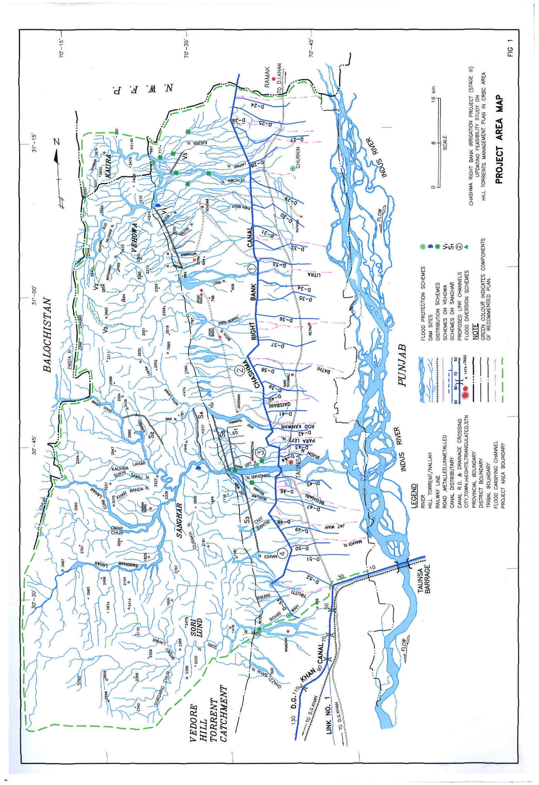

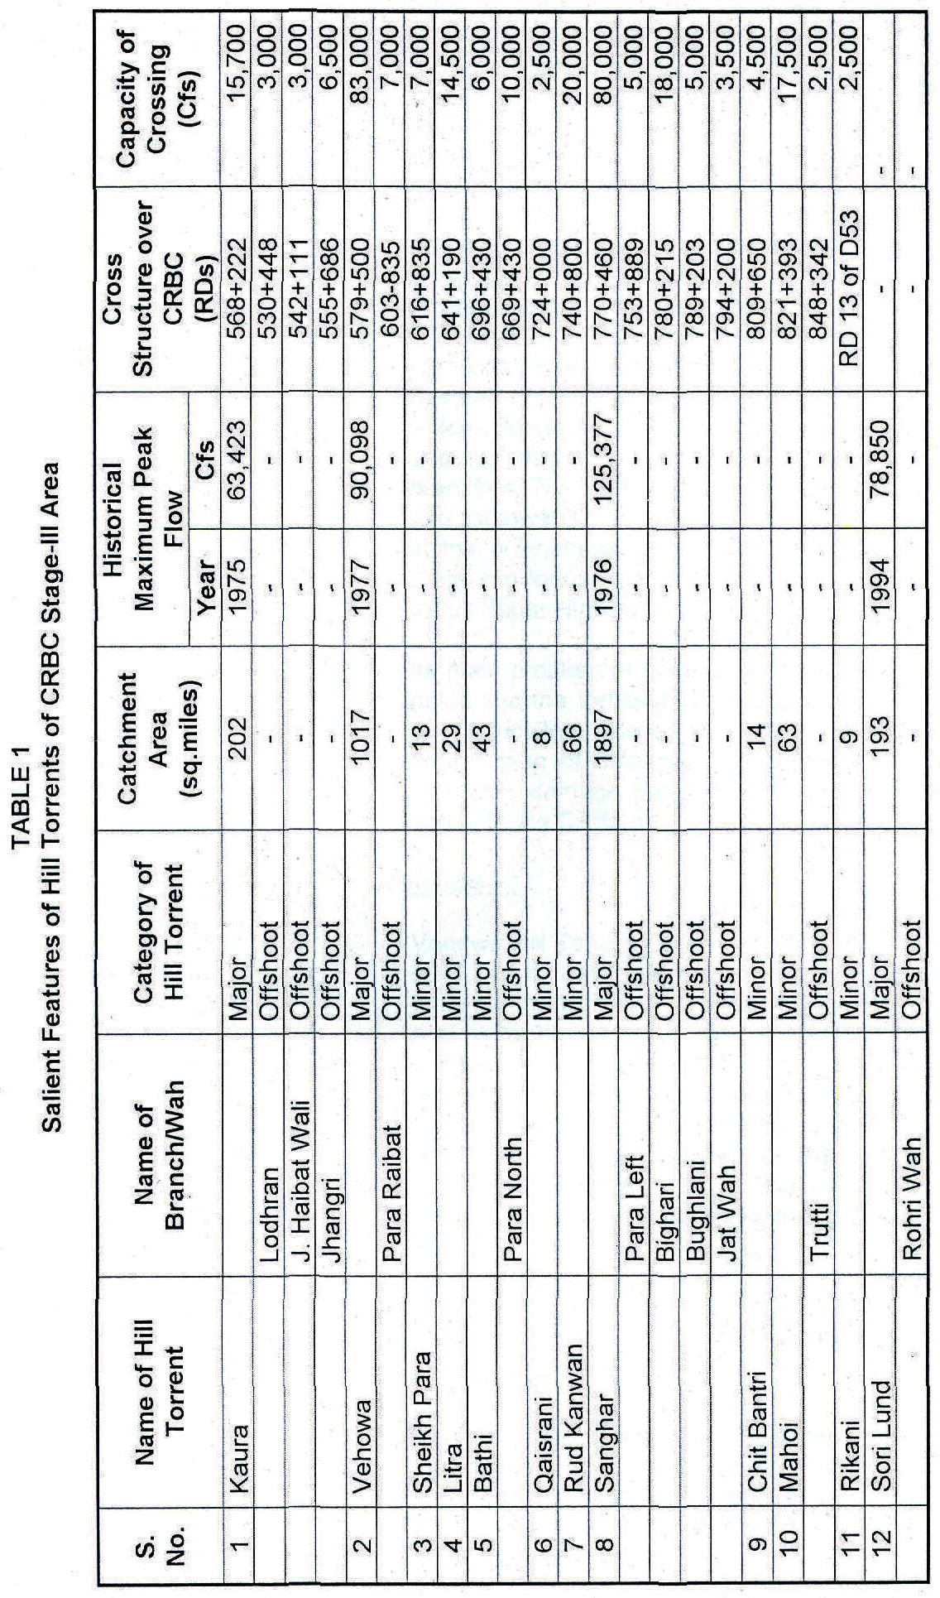
Kaura
Kaura Hill Torrent Basin is situated at the northern extremity of the Project area. It is the only basin of the Project which shares area from the three provinces of the country — Balochistan, NWFP and Punjab. However, the submountainous and plain area of the basin lie in Punjab Province where it debouches from its “Darrah” and fans out to disperse its flows. Kaura Hill Torrent originates from an elevation of 2,860 m (9,385 ft) in the form of a small stream in Balochistan Province. The stream flows southward and after covering a small distance takes an eastward turn. Hereafter, the flow direction remains almost same upto its confluence with a neighbouring torrent on its right.
The torrent retains the name of “Guzai Rive” up to its crossing of the Provincial boundary of Balochistan, where it receives the flows of Mashkha Khwar from the left. After the union, it enters NWFP and assumes its name as “Kaura” which continues to receive flows of a number of small streamlets from both the sides, and enters Punjab Province a little above the Darrah. After passing through the Darrah, it bifurcates into two branches. The right branch delivers major part of its flow into Vehowa Hill Torrent and aggravates flood problems in the downstream areas. The flows of the left branch drain into Indus River after crossing the CRBC and the Indus Super Highway.
Its main problem at present is to prevent its flows from going into the Vehowa Torrent and to utilize these flows for agriculture development in Pachad area by construction of dispersion structures which will reduce the flood damage potential and thus will also provide safety to the CRBC.
Vehowa
Vehowa Hill Torrent rises at an elevation of about 2,360 m (7,743 ft) near Atal Kach in Balochistan Province. It flows northwards for a small distance. After flowing past Atal Kach it takes a right direction and crosses DI Khan — Musa Khel Road near Toi Sar. Up to this point, it receives flows of Nigande Lahar and Zam Khawara from the left; and Tsapparai Mastai, Razanni River and Khezai Lahar from the right. Just below the road crossing, the torrent receives the flows of Loa Lahar from the right, which collects flows from the following small tributaries:
• Zindai/Tang Lahar; • Tor Haranch;
• Wangarah; • Haranch Lahar; and
• Sherani; • Sewe Khwara
• Darwazai Lahar;
Hereafter, the torrent flows eastward near Khundai Kili and assumes a wavy path, upto Punjab — Balochistan provincial boundary. Just above the boundary, flows from Badri Nallah Shavan Khwar and Pasta Nallah join the main torrent.
Below the confluence, the main stream takes almost northward turn and flows down to receive Kaura flows, whereafter it again turns eastward and fans out after crossing the Darrah. On its way to the Indus River, it crosses CRBC and the DI Khan — DG Khan Highway. Total catchment area of Vehowa is nearly 2,634 sq.km (1,017 sq.miles). From the point of view of catchment, it ranks second in the hill torrents of Project Area.
The flood flows of this torrent cause the following flood problems:

• Out flanking and damaging the Vehowa Pick up weir;
• Flooding of “non Haqooq area”
• Depriving the Haqooq, area from water rights
• Damaging the CRBC command area.
Below the weir, flood flows usually damage the earthen bund put across “non haqooq”, channel for diversion of flood flows to “haqooq” channel which consequently deprive the area of basin irrigation. Therefore its main problem is to train the torrent by providing proper flood management measures which would also improve the basin irrigation.
Sanghar
Sanghar is the largest hilt torrent of the area with a catchment of 4,913 sq.km (1,897 sq.miles).
The torrent springs from a mountain of Suleiman Range at an elevation of 1,915 m (6,285 ft). The stream flows in a north-eastern direction for some distance and then takes a “U” turn towards south-east. About 15 km down, it again turns after receiving flows from the following torrents from the right.
- Tirkh/Artangiwar;
- Tirkhan Lahar; and
- Bud Rod.
The following major tributaries join it from both sides up to the Darrah.
● Khajuri Rud ● Kannokai;
● Lori Tangi; ● Indarpur / Luni Lahar;
● Zer Tangai; ● Naval Chur;
● Kingri River; ● Binar Chai;
● Rud Lahar; ● Sanghar Lahar; and
● Machihin Sarin Lahar; ● Drug Lahr.
Main satellites of the area are Khan Muhammad Kot, Haran Bore, Mangrotha and Taunsa. The hill torrent is divided into three parts below Darrah. The torrent crosses CRBC and Indus Super Highway; and outfalls into the Indus near Taunsa Town. The improper distribution at various sites is the major problem of the hill torrent.

Sori Lund
Sori Lund Hill Torrent has a catchment area of about 500 sq.kms (193 sq.miles). It rises in Suleiman Range at an elevation of about 2,068 m (6,785 ft) above msl in Punjab Province. A number of small branches join to form the main stream about eight kms down from its origin. The stream adopts wavy path but mainly flows in eastern direction receiving flows from numerous small nullahs from the right and left. After coming out of the hills, two wahs called Rohri wah (left) and Heeden wah (right) offtake from the torrent, The flood flows of Rohri wah are utilized in Pachad Area by constructing small groyne/diversion bunds. These bunds get damaged which result in inundation and damages of CRBC and its command area at the tail. Whereas, flood flow of Heeden wah does not affect the Project Area.
MINOR HILL TORRENTS
Apart from three major hill torrents and an off-shoot of Sori Lund, which is called “Rohni Wah”, eight (8) minor hill torrents/churs cross the CRBC. Most of them have separate catchments in the hilly area and thus debouch onto the Pachad Area through their own ‘Darrahs’.
All of the major and minor torrents/churs have 21 separate cross-drainage structures over Chashma Right Bank Canal which have been connected to the flood carrier channels across the CRBC. Some of these channels have been excavated up to the Indus River while some others still need to be connected to the river. These streams along with their salient features have already been listed in Table 1.
i) Area and Population | The entire Project area is about 3,500 sq. miles. According to 1998 Population Census, the total population of the Project area is as 77,546 persons with 39,621 males and 37,925 females. The average growth rate of population is 2.87% in Pachad area and 2.55% in hilly area.
 | Mostly, the people speak Siraiki (an area specific form of Punjabi), while Baloch, Sindhi and Pushto are also spoken by very small fractions of population.
ii) Physiography | The Project area located in DG Khan can broadly be divided into three major physiographic units viz;  - Mountain Ranges  - Pachad Area  - Canal Command Area/Indus Basin

- Mountain Ranges
This zone includes gravelly fans, mountainous slopes, valleys and plateaus. The mountain ranges occupy the western periphery of the project with the Indus running parallel to the foot hill all along. The area is drained by more than one dozen hill torrents of which 4 are major. Hill torrent flooding is the main problem for human settlements, crops and infrastructure in CR80 command area.
- Pachad Area
Pachad area is sandwiched between the mountain region and CRBC command area. This area has been formed by rich alluvial deposits brought by hill torrents from the Suleiman Range. Basin irrigation is practiced since the time immemorial by constructing bunds around the field to store three to four feet of water. The general slope of this area is from West to East.
• Canal Command Area/lndus Basin
The belt of thick and fertile alluvium has been formed by the Indus river. The main features are the aggrading channels of hill torrents and gently rolling area, generally covered by clayey deposits. These flood plains are characterized by flat land form criss-crossed by a network of irrigation canals.
iii) Climate | There are a few rainfall measuring stations in the Project area which record precipitation with an interval of 24 hours. None of these stations records any other meteorologic data. However some synoptic stations exist around the Project area which possesses markedly prominent hydromet similarities with those of the Project area.
 | The Project area falls in arid sub-tropical continental monsoon regions characterized by distinct seasons, which are summer and winter. The mean annual precipitation is 269 mm at Dl Khan which is situated at the western periphery of the Project area. About 50% of the total precipitation is received in the monsoon season and the remainder during the rest of the year. The mean annual relative humidity remains more than 60%, for about 8 months in and around the Project area.
 | The mean annual summer and winter temperature are 24°C, 33°C and 14°C at Dl Khan, respectively whereas mean annual 25.2°C, mean summer 34.1°C and mean winter 14.1°C temperature have been recorded at Multan. The hottest month is June with mean maximum temperature 41.5°C and 42.3°C, whereas January is the coldest month having the mean minimum temperature of 4.2°C and 4.5°C at Dl Khan and Multan metrological stations, respectively.

iv) Geology | The geologic formations in the Project area generally comprise Quaternary deposits and Tertiary deposits. Quaternary deposits are relatively younger, unconsolidated deposits consisting of river and piedmont alluvial sediments with unknown thickness. However, the gravelly deposits are thick and occur close to the mountains. The alluvial plains substrata are predominantly sandy, that of the floodplains are homogenous and the one of the piedmont plains are heterogeneous comprising alternating layers of sand and clay. The silt and gravel are presented in thin layers.
 | The tertiary deposits are consolidated sedimentary rocks, light green/grey to green shale, interbedded with sandstone and gypsum; alternate beds of greenish/grey clays and soft friable sandstone, with intermittent deposits of conglomerates.
v) Soils | According to Soil Survey of Pakistan’s reconnaissance surveys of the Project area carried out in 1969 and 1974, about 19.1% soils of the Project area are coarse, 13.3% moderately coarse, 27.4% medium, 14.2% moderately fine and 26.0% fine in texture.
vi) Irrigation | The intermittent and erratic patterns of precipitation events, being the unique source of stream flow irrigation, have become the sole basis for the evolution of ‘Kamara Irrigation System’ since centuries. This system enforces the sequential water rights and dictates the irrigation pattern from upper to lower riparians, without consideration of the duration and magnitude of the storm generated flow. Under the system sometimes, the far filing lower riparians remain deprived of irrigation facilities during a low flow year. None-the-less, the system is hardly capable of managing the low flows, whereupon the medium and high flows destruct the farmer’s earthen diversion arrangements; the flows rush down assuming the shape of floods which usually cause unprecedented damages to the local economy. The wastage of irrigable flows and the resultant loss of edible, potable and encashable agricultural production, coupled with the flood losses being inflicted since centuries together, is well presented by the current socio-economic parameter and the existing standard of livelihood of the locals of the area. The gross command area, comprising all the major and minor hill torrents is about 281,000 acres which includes the culturable area of about 235,500 acres. Still the cropping intensity remains 8-12 percent under the existing Kamara system, the actual yearly cultivated area varies hardly from 20-30 thousand acres. This area utilizes only a friction of the hill torrents annual runoff which approximates to about one and a half million acre-foot when assessed against a 25-year recurrence.
vii) Groundwater | The soil and water testing laboratory of DG Khan is responsible for the data/information regarding groundwater. According to the information supplied by laboratory sources, only 32 percent of the DG Khan area contains groundwater fit for irrigation. Another 9% is only marginally fit, whereas the remaining 59% is absolutely unfit for crop production.
viii) Drainage | No considerable waterlogged areas are reported within the Project limits. However, the natural drainage of the area is from West to East i.e. from mountains towards Indus River. Chashma Right Bank Canal has created a natural obstruction across the flow lines of the hill torrents. The cross drainage structures provided therein, do not serve the purpose adequately. They are either located offsite or are placed at a higher level than those of the hill torrent channel beds.
ix) Agriculture (crops, yields, etc.) | Agriculture in the Project area is predominantly rain fed. Only 12% of the total cultivable area is presently irrigated. Agriculture in the area is below subsistence level. Major crops are millet (jawar/bajra) covering about 40% of the cropped area followed by wheat representing 23%, gram 22% and 15% other crops. Crop yields in the Project area are very low, mainly due to uncertain and erratic amount of water at critical stages of crop growth, non availability of improved seed, inadequate use of fertilizers and pesticides, in sufficient cultural practices, lack of credit facilities for the purchase of farm inputs, lack of modern technology for land-crop-water management.
 | At numerous places, farmers have been diverting flood flows into small channels for irrigation purposes since decades, but many have become dysfunctional due to physical, technical, financial and social constraints. Most of the water is wasted by runoff through hill torrent streams which during floods often cause damage to land and life and end up in lndus River. Because of this the lands of Project area are not being utilized according to their potential. Without proper management of water resources, subsistence level of farming would perpetuate causing thereby more deterioration in the socioeconomic condition of the farming community.
x) Any other Relevant Economic Characteristics of the Area | Economy of the Project area is almost entirely based on agriculture and livestock. It is thus affected by the cropping pattern largely controlled by availability of water and mode of irrigation. Lack of communication facilities, illiteracy and other infrastructure are the cause of low standard of living for the greater part of the population and the main constraints in the development of the area.
 | Majority of the population lives in the rural areas and depends upon agricultural production through regulated supplies from CRBC and Hill Torrent irrigation in Pachad Area. The canal water supports almost a regular cropping pattern in the canal irrigated area, while rainfall generally sustain a varying cropping pattern depending upon the season and its duration in Project area.
 | The main products in canal irrigated area are cotton, rice, wheat and oilseed whereas Sorghum, Wheat, Pulses, Oilseeds and Livestock (meat and wool) are of Pachad Area.
 | Mode of communication and transport charges affect the economy considerably. The market value of produce in the villages is about 10 to 25 percent lower than the trading centres depending on the mode of transport.
12. Problem to be Solved | The Project area has been facing absolute water shortage since centuries. The water shortage has not only affected the agriculture sector but also various aspects of social sector including human life, health and environment. The dearth of potable drinking water is worst scenario of the problem. However, the problem of water shortage is far more than the availability of water. During rain season, the hill torrents swell up due to heavy floods which are exceedingly larger than the manageable capacity of the farmers. These flows are wasted unutilized. Rather, these wanton flows inflict severe flood damages enroute to Indus. The structure of the Project has been planned and designed so as to:
• provide effective management of flows of hill torrents for irrigation through distribution/diversion arrangements,
• prevent flood damages to private/public properties, infra-structure and communication system etc.
• to boostup the local economy.
• to create social confidence among the locals.
13. Solutions (Basic Purpose of the Project) | The updated feasibility studies have provided the most optimal solution to the problem, whereby all possible alternate solutions were evaluated. The most feasible and cost effective solution has been adopted for execution. This comprises:
• Utilization of flood flows for agriculture through distribution/diversion structures in Pachad Area;
• Disposal of excess flows to Indus by channelization through CRBC command area, and
• Flood protection measures for vulnerable areas.
 | This was valid for major hill torrents only as the discharges of minor hill torrents are already managed by the farmers and as such structural measures are not needed.
14. Description of the Engineering Projects (supported by technical background data). Each distinct segment of project should be described separately. | A seriatim description of the proposed Project structures/works is presented as below:  KAURA HILL TORRENT  Sad Loharan
 | There is no offtake immediately below ‘Darrah’ of Kaura Hill Torrent. However, a little below Darrah, an undesired offshoot has been developed wherefrom a considerable part of the flows of Kaura overspills towards right, short-circuiting its route to Vehowa Hill Torrent. The overspills of Kaura on joining Vehowa flows, aggravate the flood situation in downstream areas and inflict lot of damages. On the other hand, Kaura areas remain dry for want of flood irrigation.
 | Presently, a pair of parallel stone masonry walls, filled with stone/boulders has been constructed in a length 560 feet to check this erosion. In continuation and downstream of the wall, a stone filled earthen embankment comprising local coarse material has been constructed in a length of 3,600 feet. The total top width of the wall and that of the bund is 15 feet. This system of bunds is locally known as ‘Sad Lohoran’. These arrangements have not been successful to check the Kaura spills completely. The existing embankment usually gets breached in the event of a high flood. In case of a low flood, water seeps out due to pore pressure and the problem remains as such.
 | In order to check the escapages of Kaura flows towards Vehowa, the Consultants have proposed a 7,760 feet long earthen embankment, starting from upstream of the existing masonry wall, up to the Kalandar Wah Complex. The embankment is proposed to be stone pitched on waterside with 2 feet gabion mattress laid over a 9” thick layer of spawl. In order to combat the direct attack of the flows on the embankment, three short stone spurs have been proposed, each having a length of 75 feet. These spurs would protect the embankment, help in sedimentation along the bund and streamline the flow along the channel.
 | Kalandar Wah Complex
 | Downstream of the proposed embankment, six wahs offtake from Kaura Hill Torrent, three on each side. These are:
● Qamar Din Wah; ● Makhan Wah;
● Kalandar Wah; ● Lakhani Wah, and
● Chango Wah; ● Khaji Wali Wah.
 | The Consultants have proposed a complex distribution structure at this location. The structure will include a cross weir and six offtakes, each leading into a separate channel.
Copi Wah

Copi wah offtakes about two kilometers downstream of Kalandar Wah Complex. This wah carries Kaura flows to the lands on right side of the torrent. The Consultants have proposed a distributor at this location with a weir across the main torrent.
Bojh Wah

Kaura Nallah has its last bifurcation near Daulatwala village. Bojh Wah offtakes from the right side, whereas the main downstream channel of the torrent is known as Sakh Chaharam. A diversion structure has been proposed at this location.
 | A general plan showing the proposed structures/works of Kaura Hill Torrent is presented in Exhibit 1 and Fig. 2 through Fig. 9 present the designs of plans and sections of the proposed structures.
VEHOWA HILL TORRENT

Gang Canal

Vehowa is the second largest hill torrent of the area. Gang canal is the first rightward offtake below darrah which has the rights over perennial flow. The Irrigation and Power Department Authorities of DG Khan have prepared a scheme of widening the canal for the delivery of increased discharge. However, the scheme ties out of the scope of this study.
Kobi Wah

Below Gang Canal Regulator, a non-haqooq channel offtakes eastward but the main stream continues its northward direction and flows ahead to receive Kaura spills. Before the confluence, a channel offtakes in a north south direction which ultimately joins the non-haqooq channel. Below the bifurcation, the main stream takes eastward direction and continues to flow down about 2 kilometers where Kobi Wah offtakes from left side.

Qaisrani Wah

The non-haqooq channel mentioned above has been blocked by a bund at its head. Below the confluence of north-south channel, it assumes the status of a haqooq channel where Qasirani Wah offtakes from right. Kotani village area forms the shape of an island between this channel and the main stream, whereby the two parts of Vehowa rejoin near Mithewali Village.

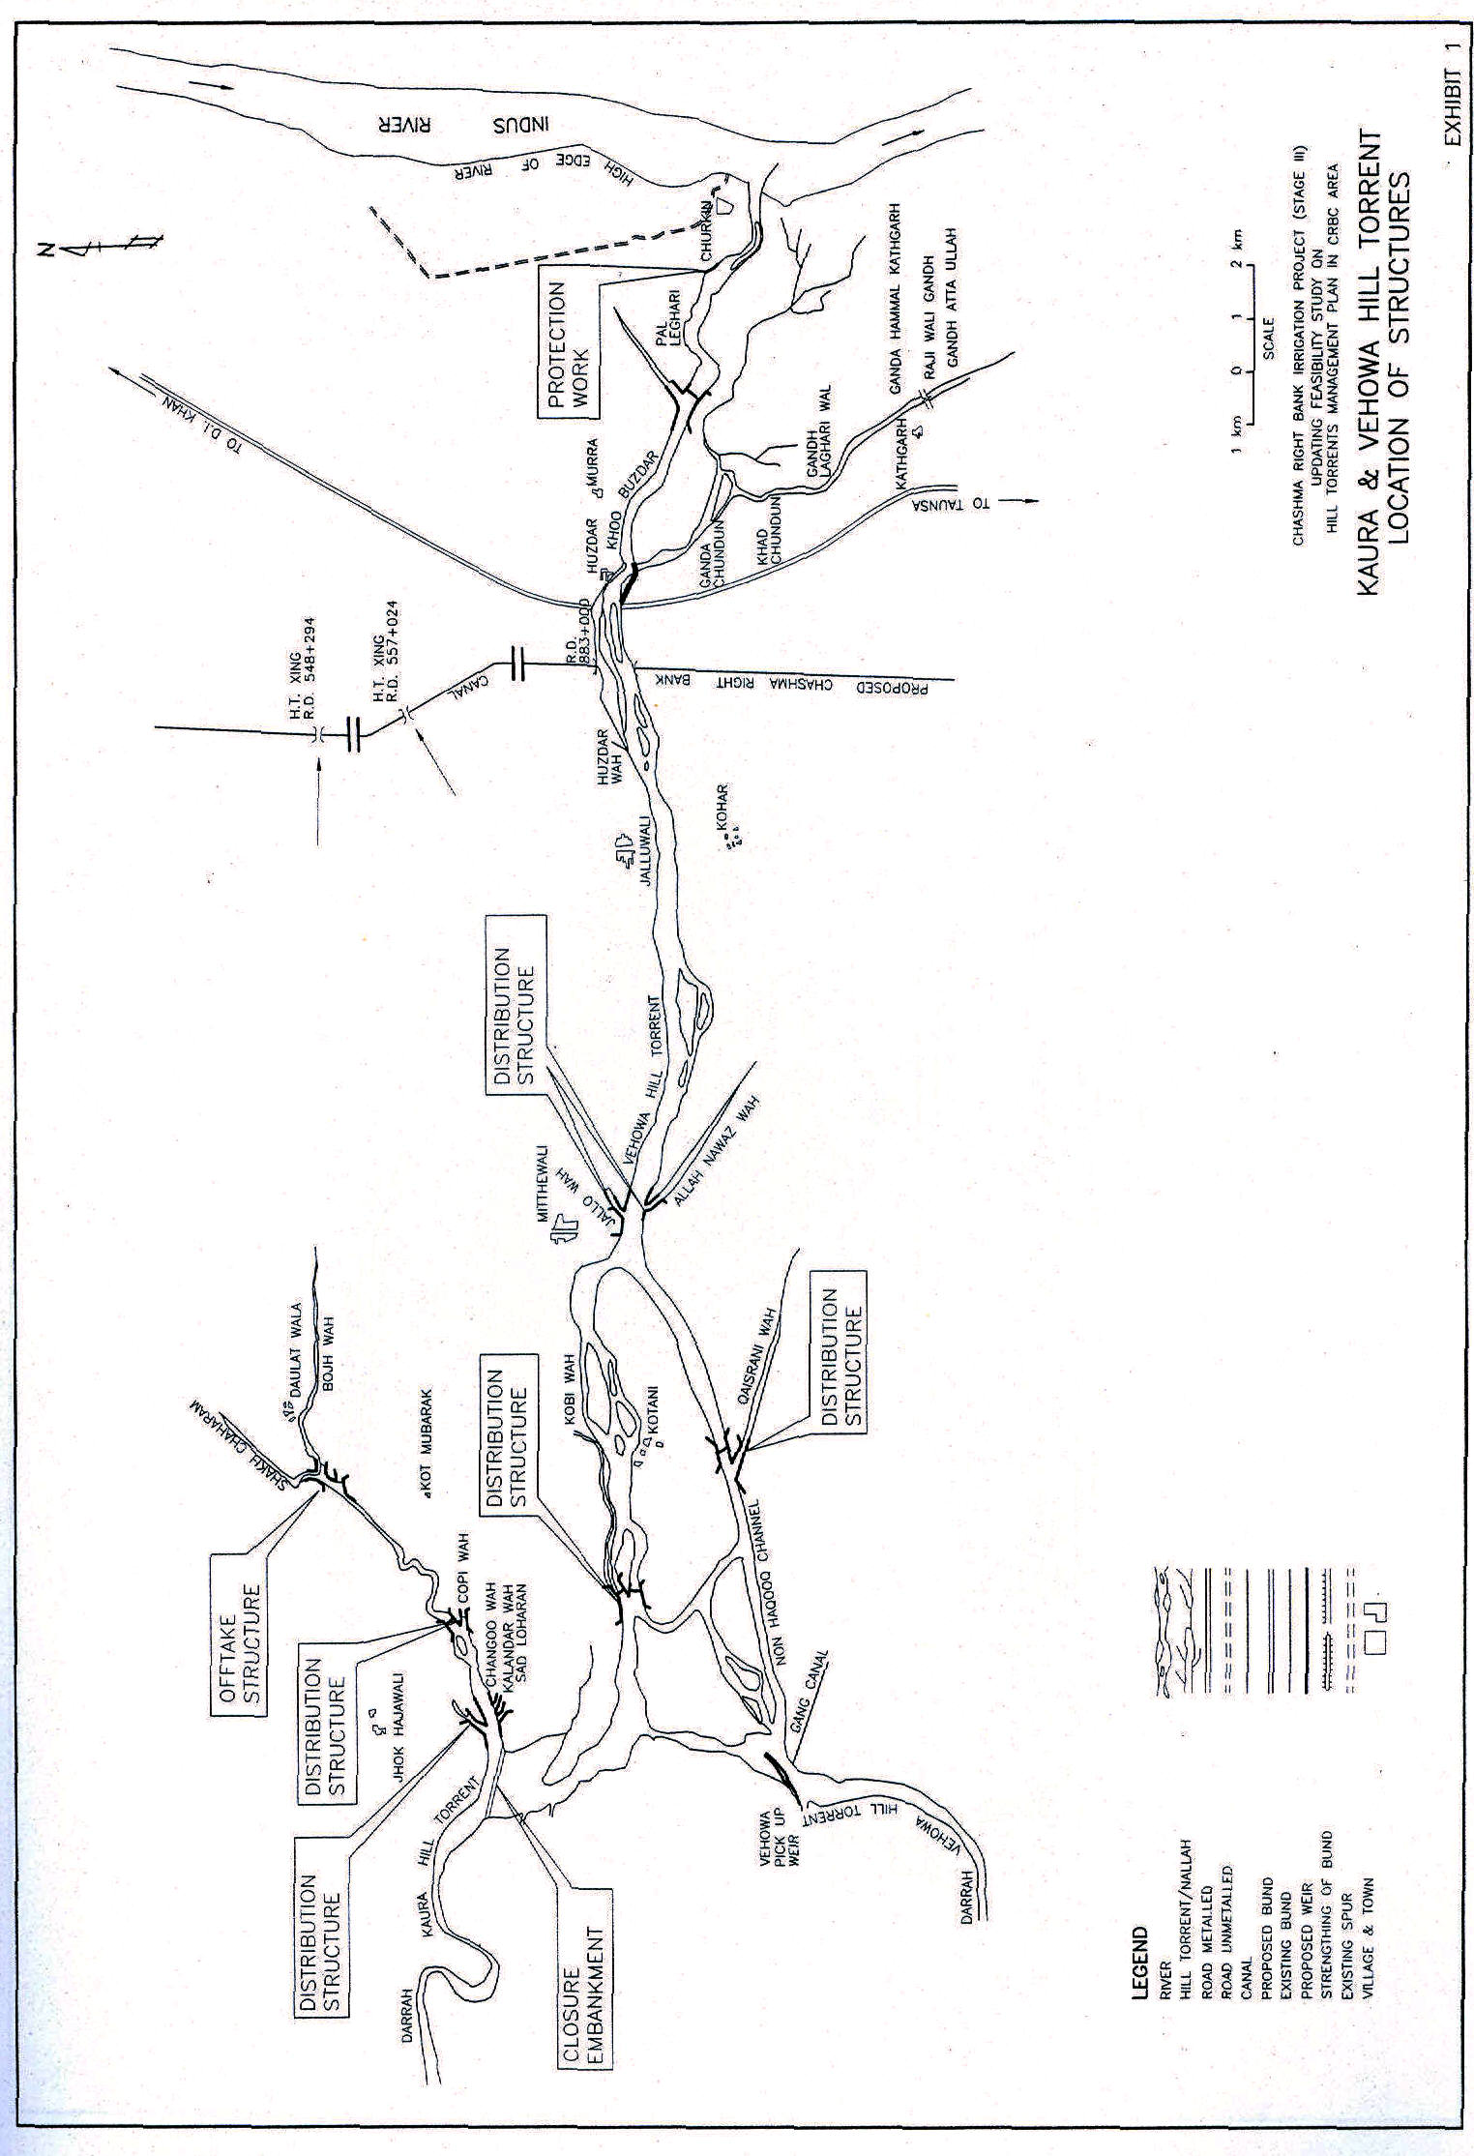

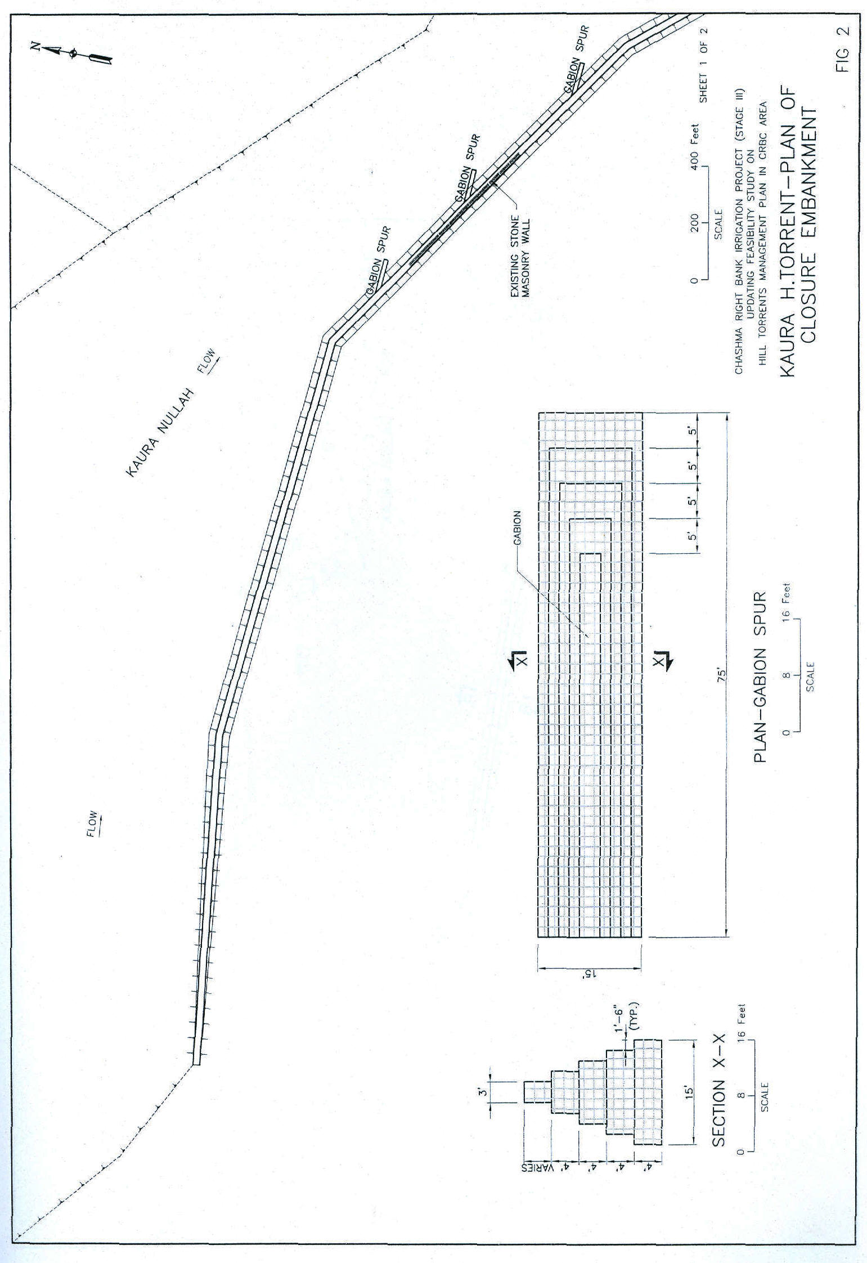

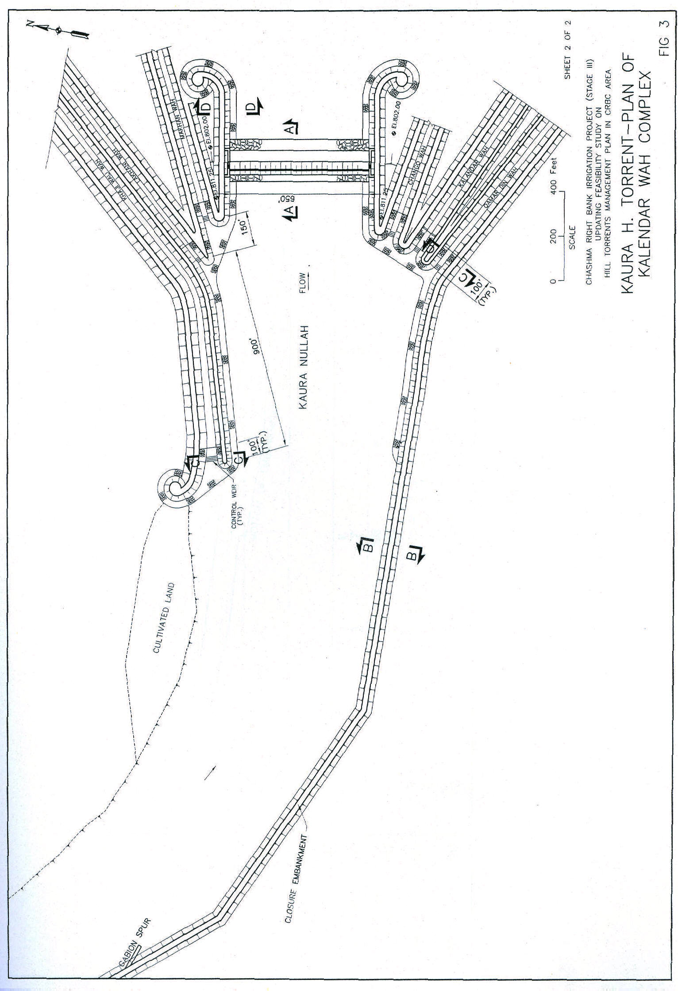

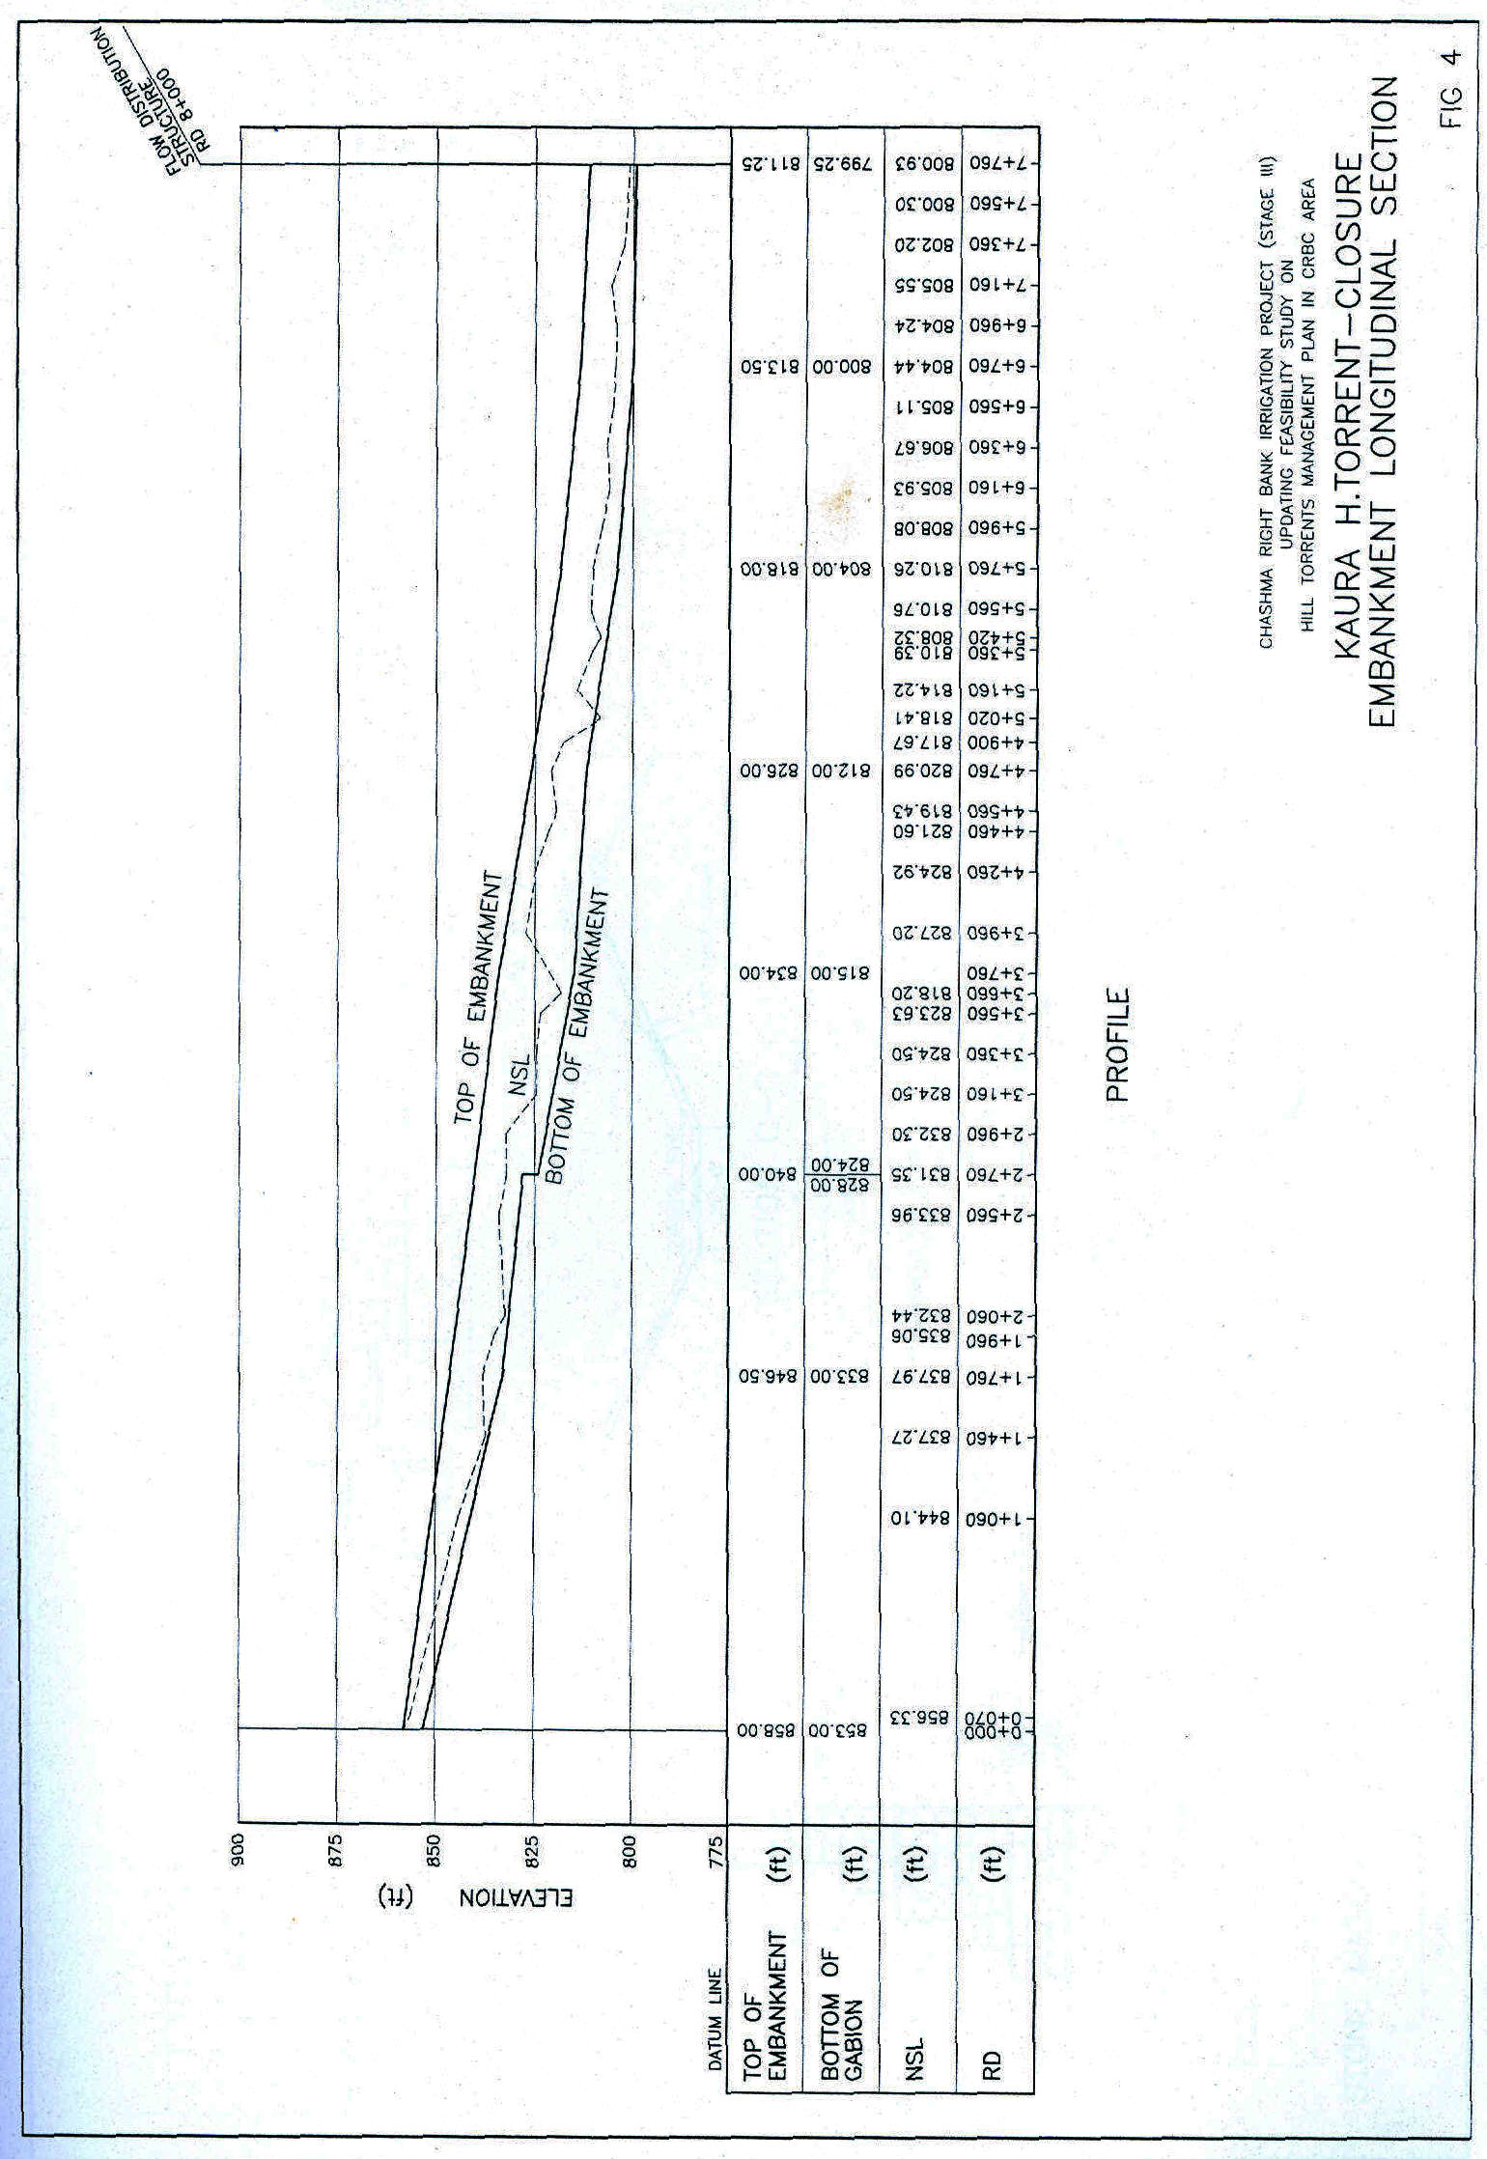

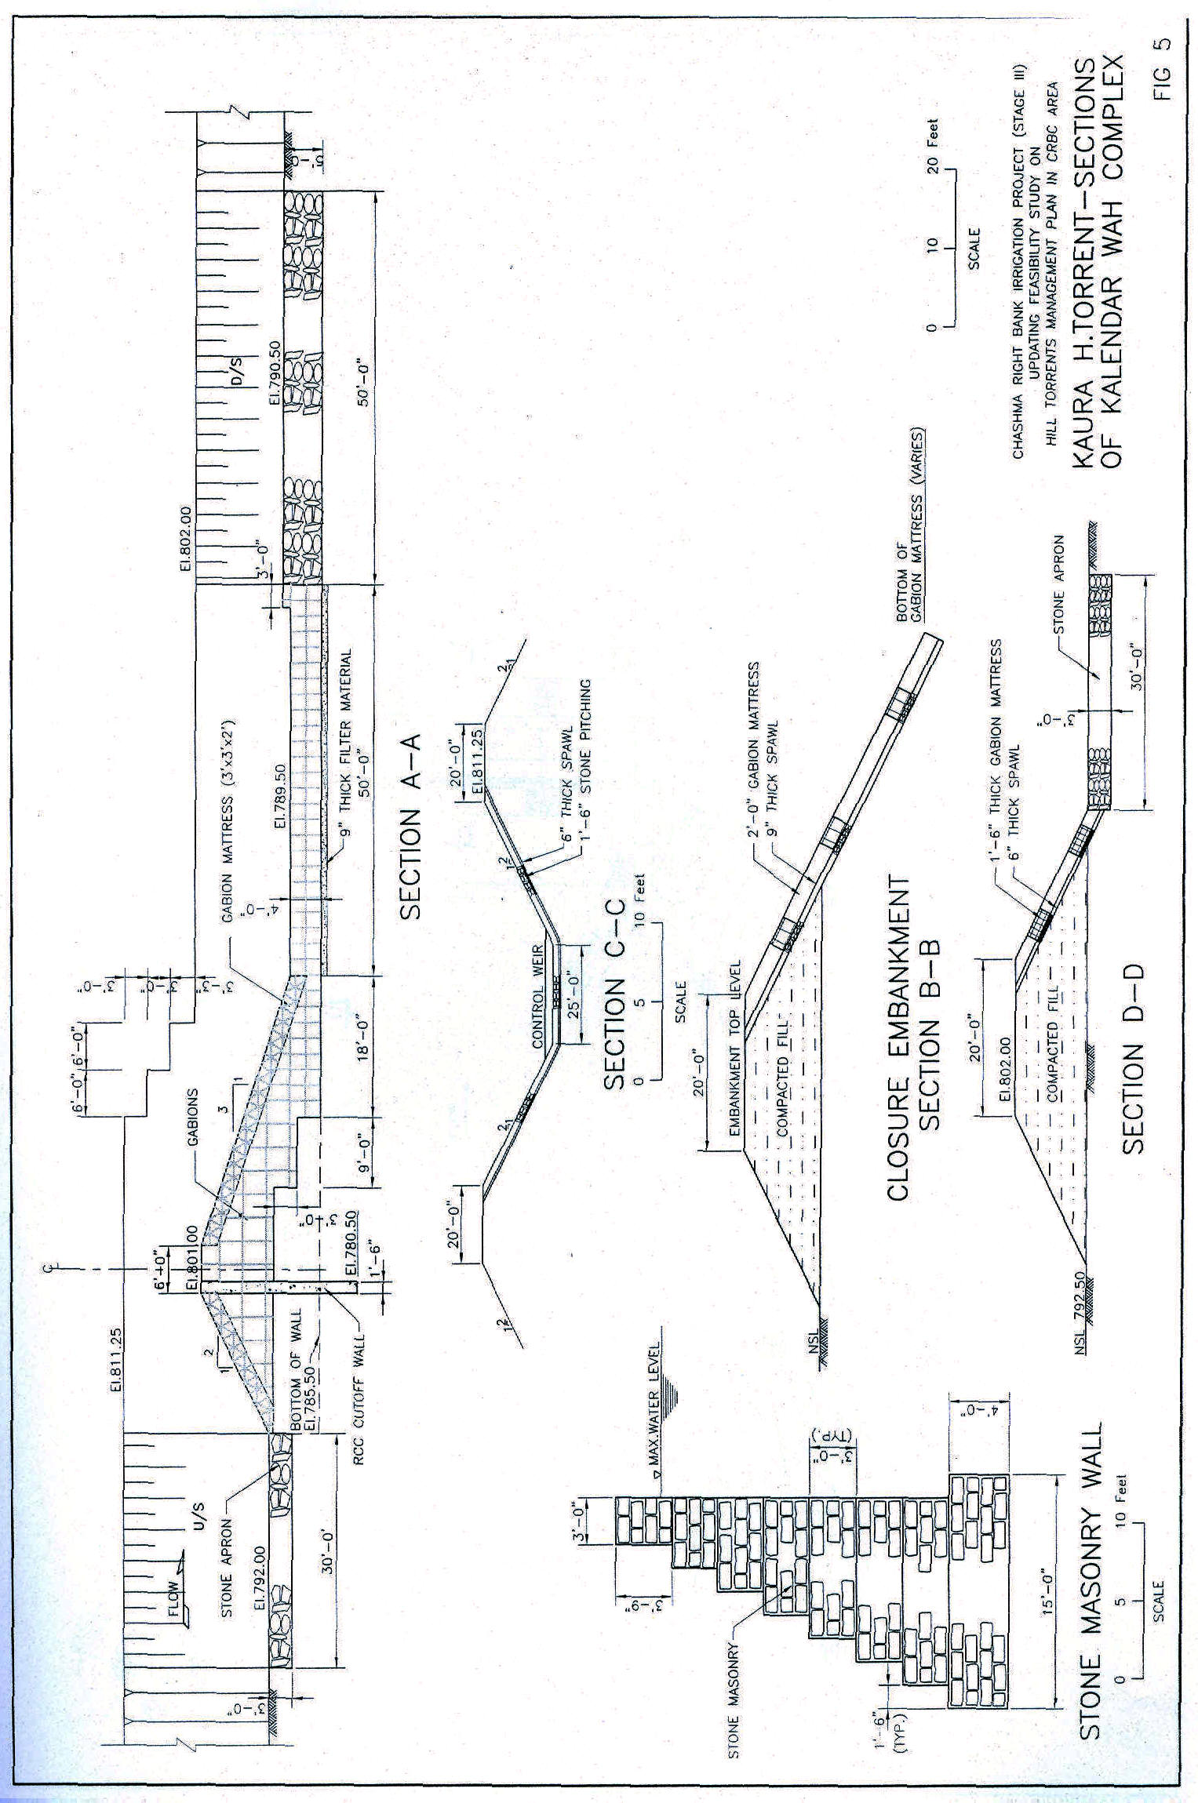
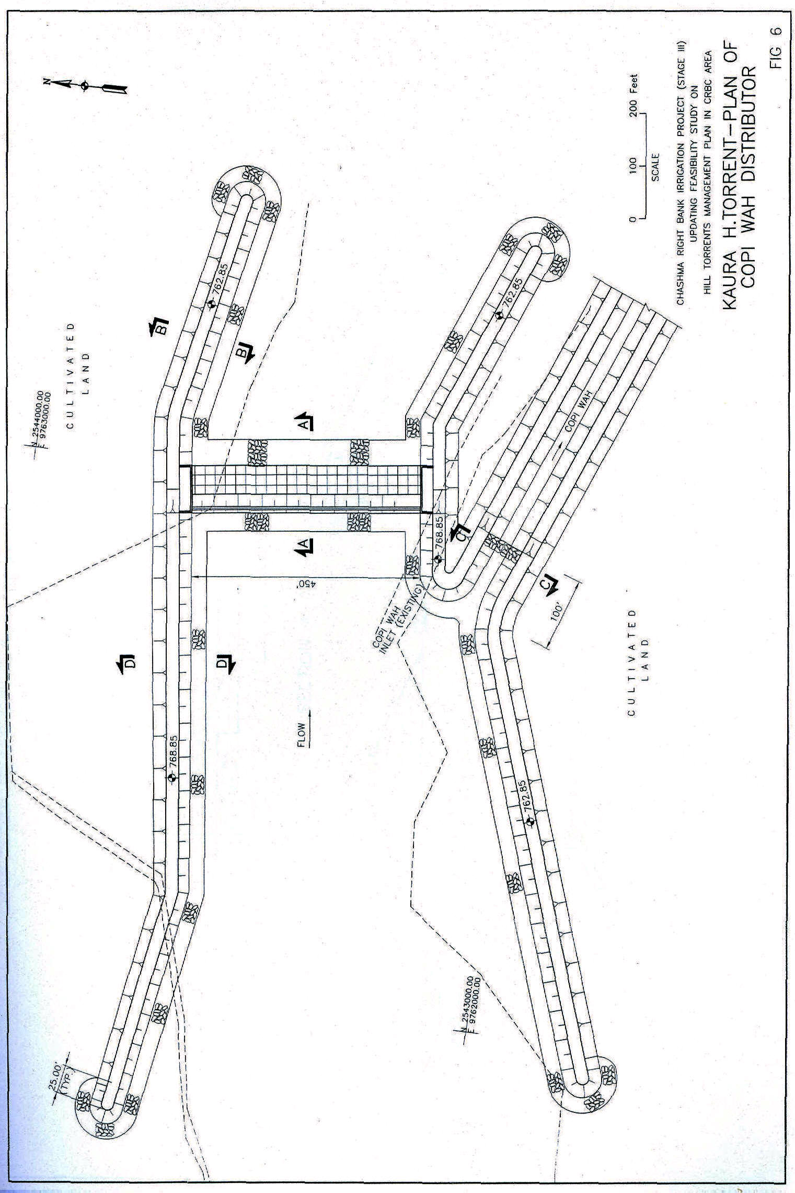
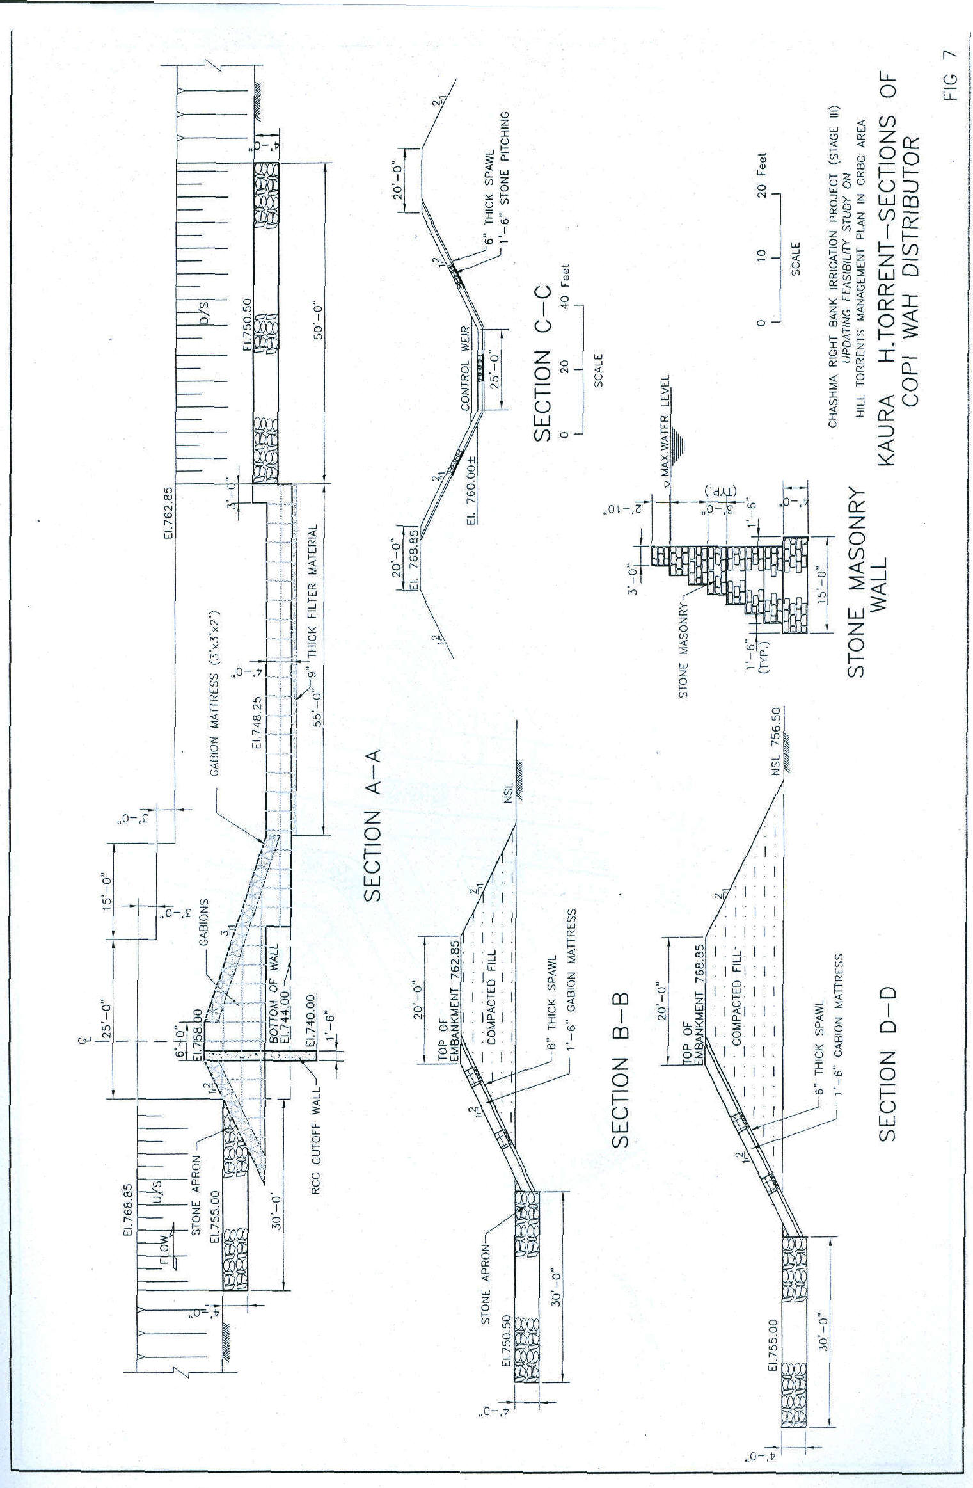
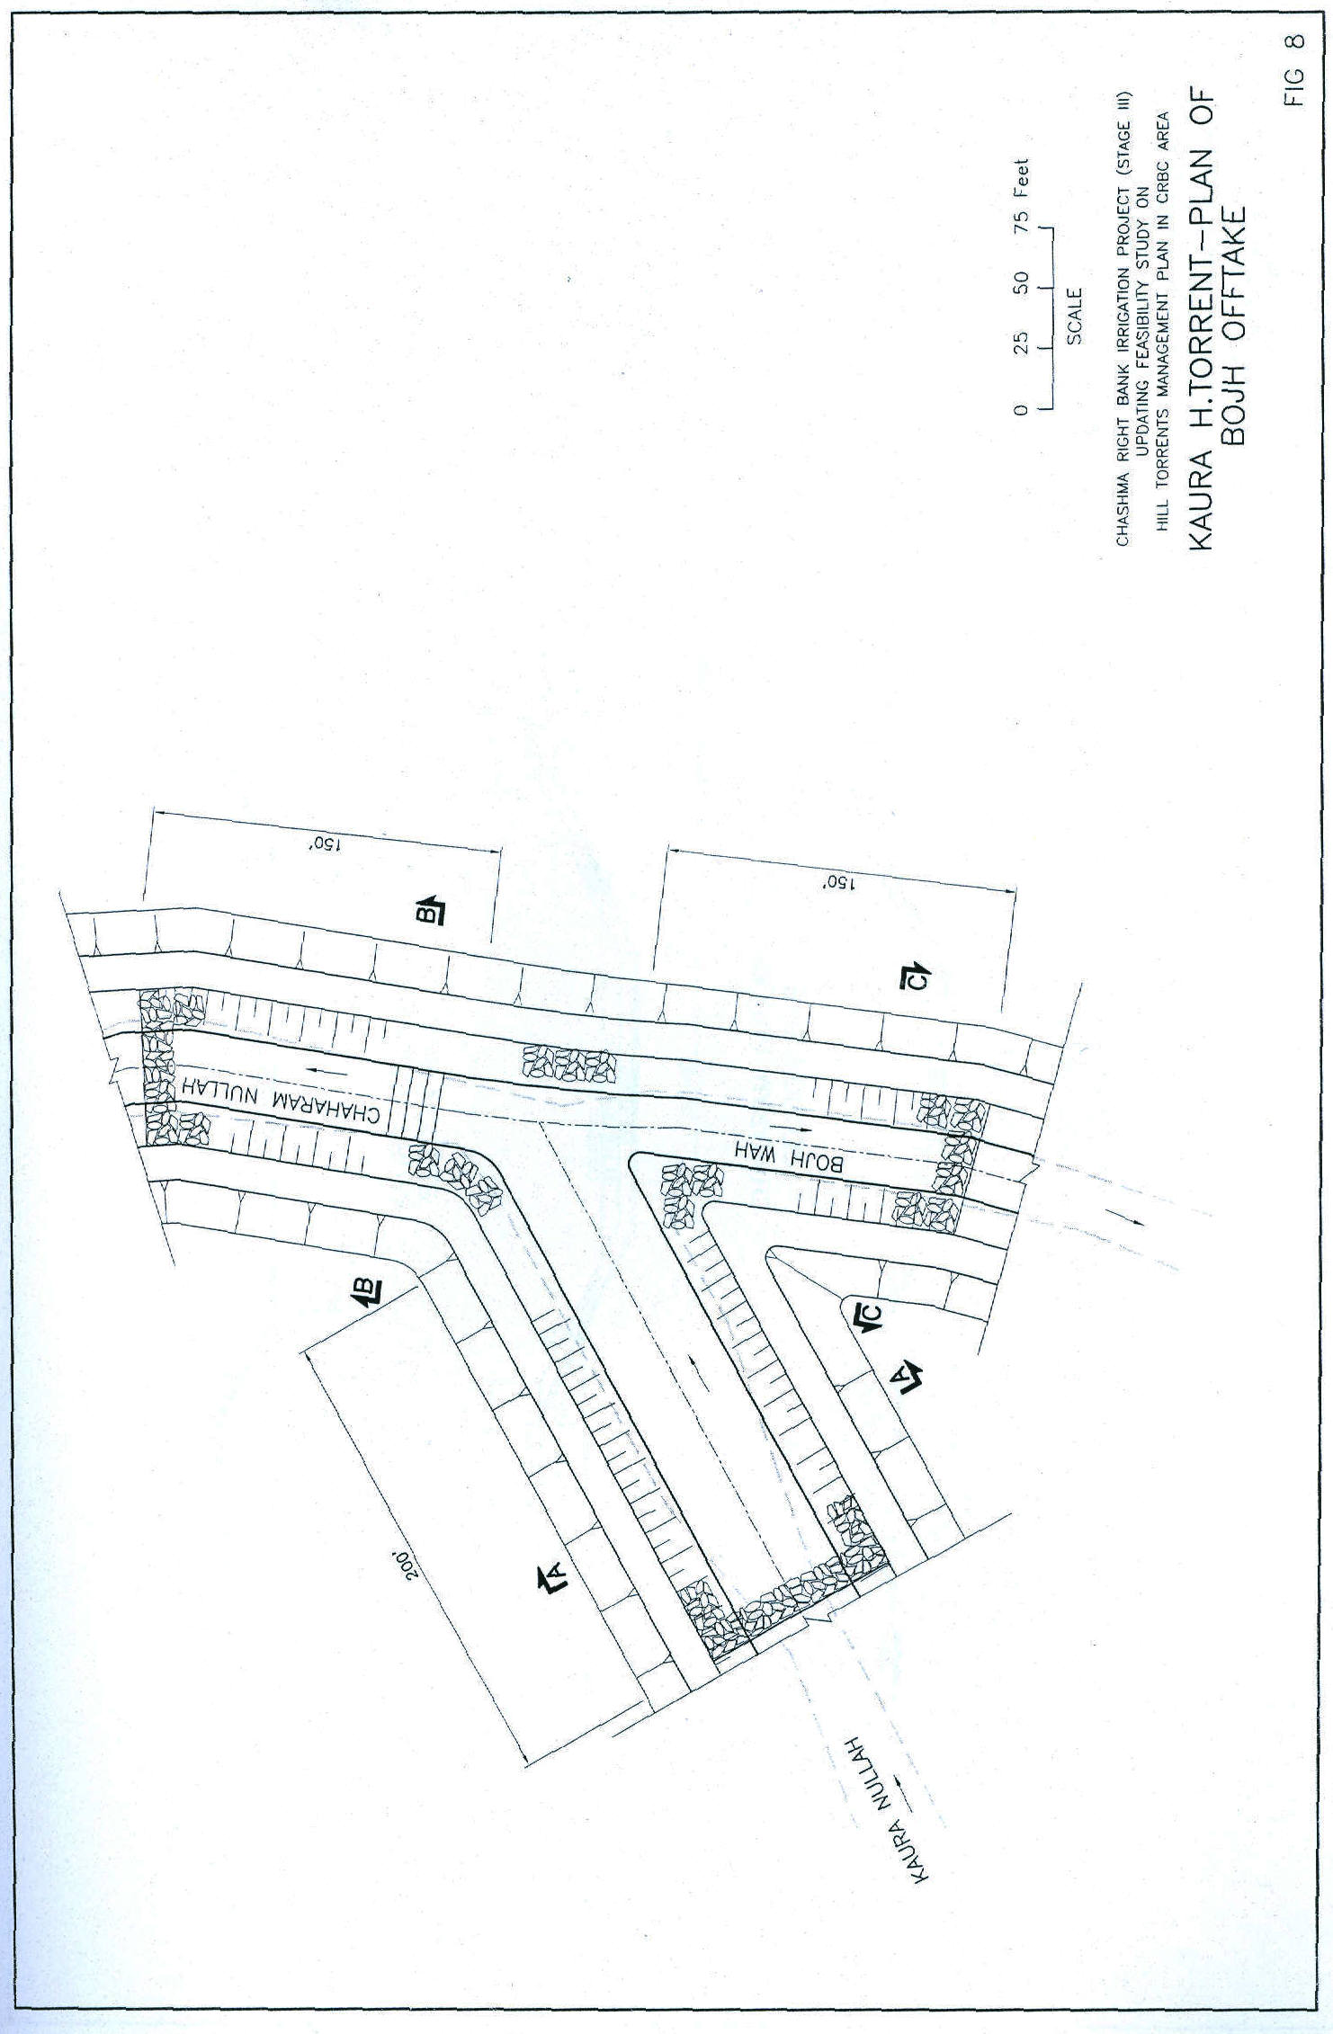
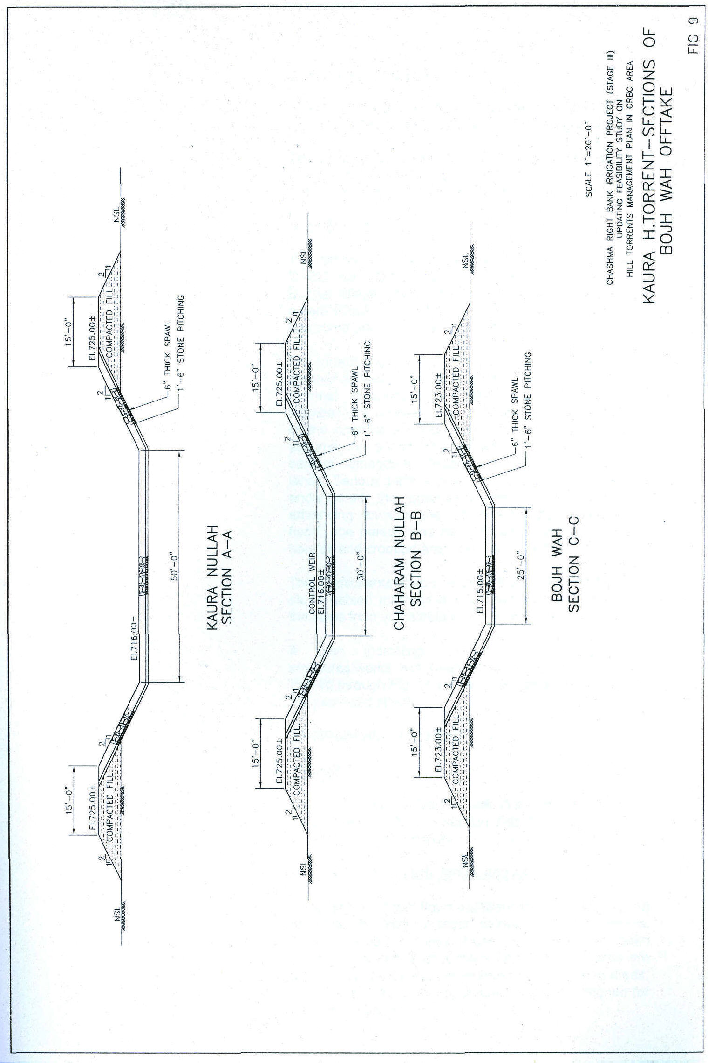
Allah Nawaz/Jallo Wah

A little downstream of the confluence, Allah Nawaz Wah and Jallo Wah offtake from right and left respectively.

Distribution structures with the cross weirs on the main channel have been proposed for Kobi Wah, Qaisrani Wah and Jallo/Allah Nawaz Wah offtake locations.
Khad Buzdar

The torrent flows past Jallo Wali Village and crosses CRBC near RD 583+000 and Indus Super Highway near Buzdar village. The torrent flows past Buzdar village and enters Khad Buzdar taking a rightward turn. This area has come under the command of CRBC.

The torrent flows up to Churkin Village and crosses it with another rightward turn. A little below Churkin, the torrent channel disappears and the extensive agricultural activities are seen all around. Due to the non-existence of the channel towards Indus River, the torrent floods assume the shape of over level runoff which inflicts serious damages to Mauza Churkin area and cultivated lands. Serious bank erosion and sloughing of land has endangered the graveyard and the embayment is advancing towards the Churkin Village. During 2003 flood, one person was reported dead and a number of houses and cropped area were damaged.
The Consultants have proposed the bank protection with stone gabion matrices and a short spur to divert away the flows from vulnerable location of the bank.

A plan indicating the locations of proposed structures/works has been presented in Exhibit 1 and Fig. 10 through Fig. 16 present the plans and sections of the proposed structures.
SANGHAR HILL TORRENT

Jat Wah

Immediately below Darrah, Jat Wah offtakes from the right banks. Offtake diversion has been designed to deliver water into Jat Wah.
Shakh Shumali, Shakh Janubi and Jam Wah

Sanghar Hill Torrent flows eastward after debouching out from Darrah. Within a reach of two to three kilometers, Shakh Janubi, offtakes from right whereas Shakh Shumali and Jam Wah offtake from the left. These are the major offtakes and command larger cultivated areas. A combined distribution structure has been designed for the three channels.

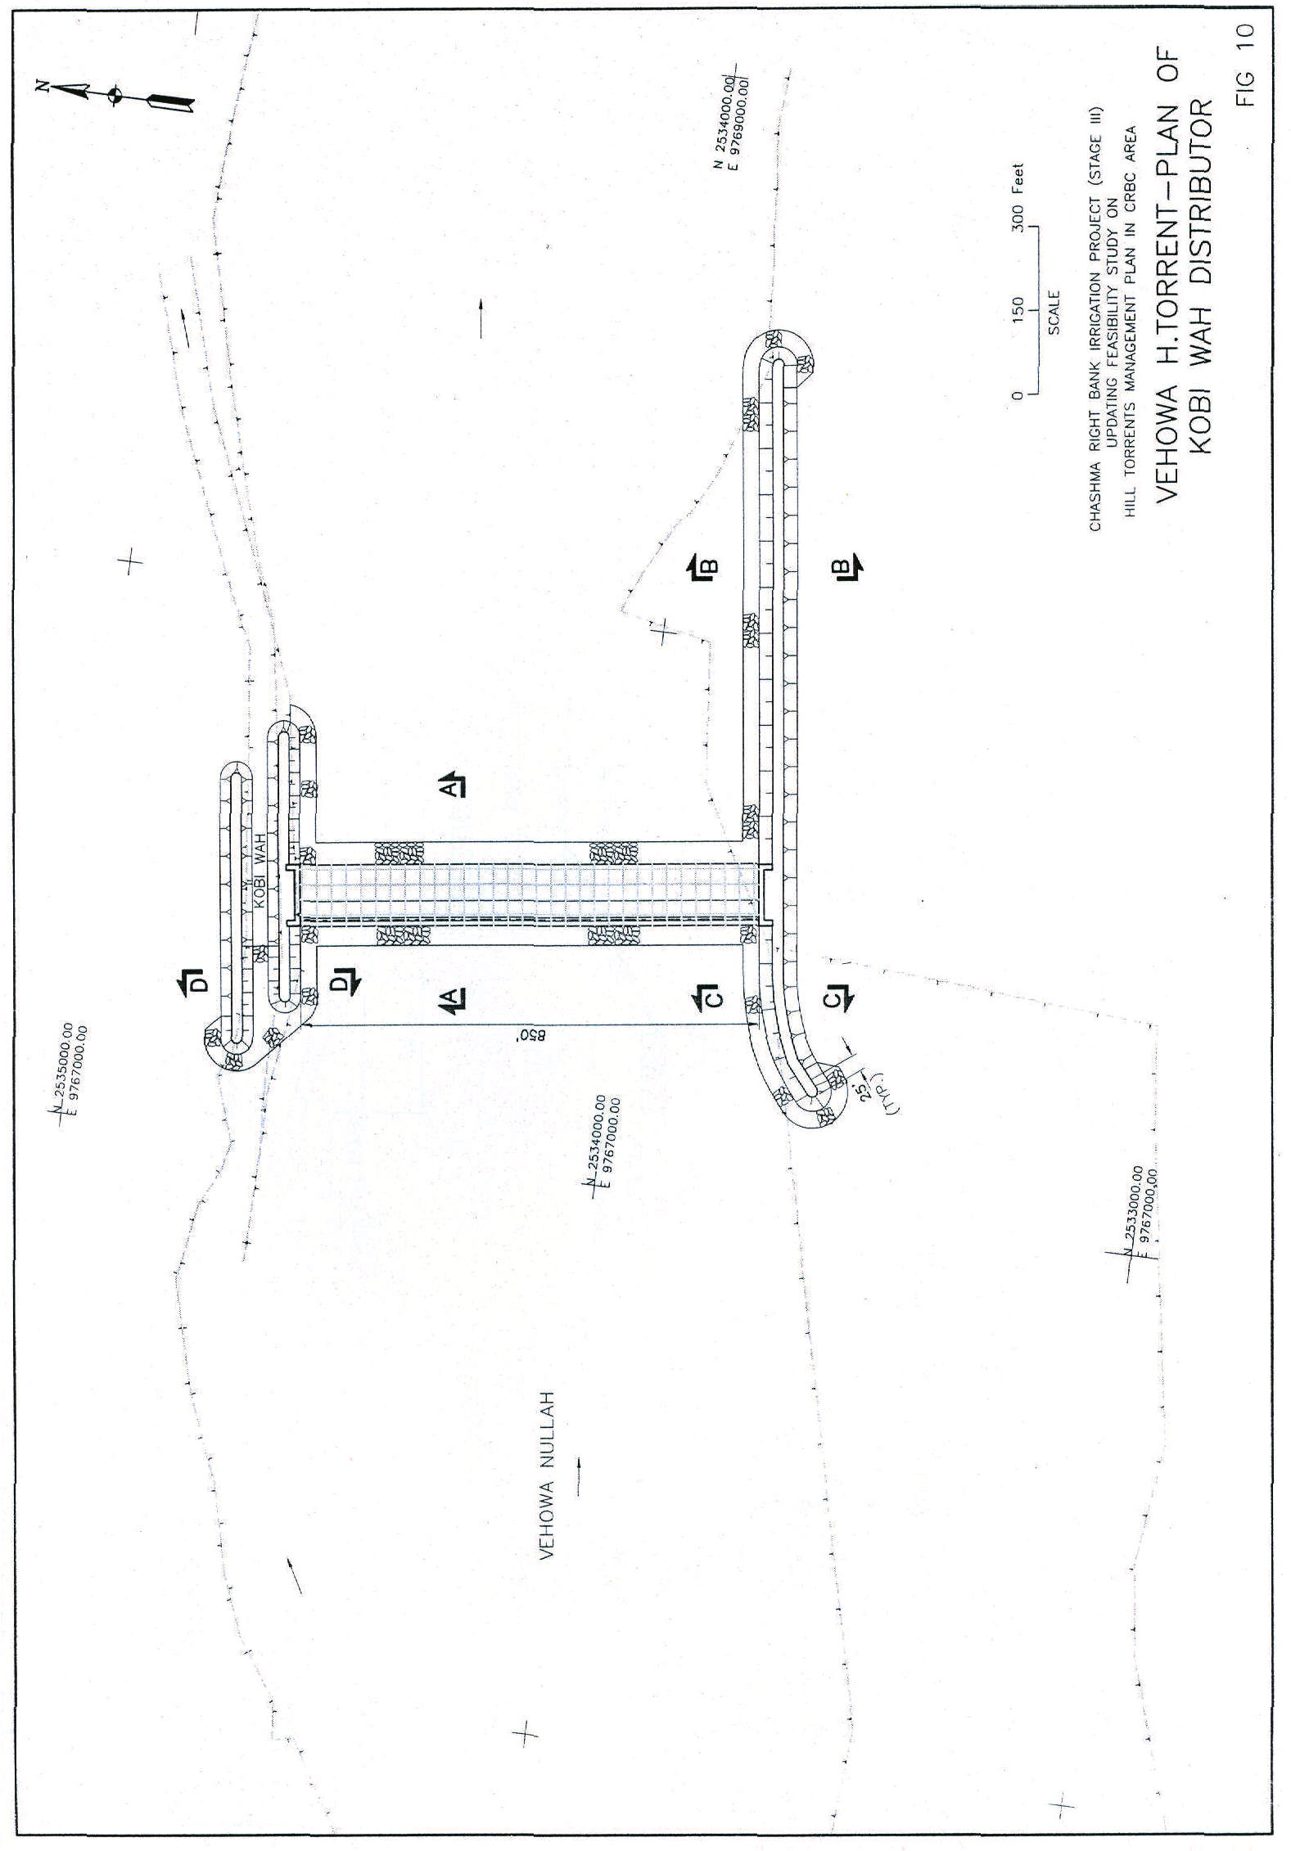

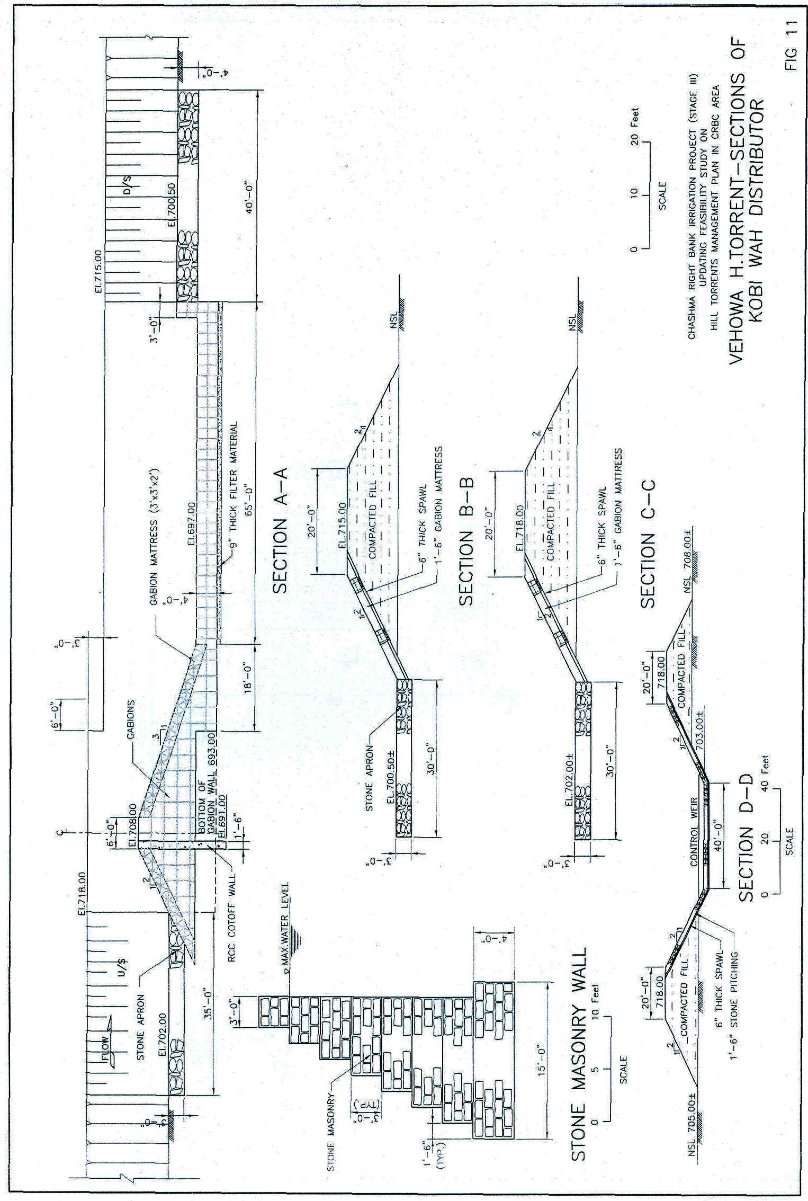
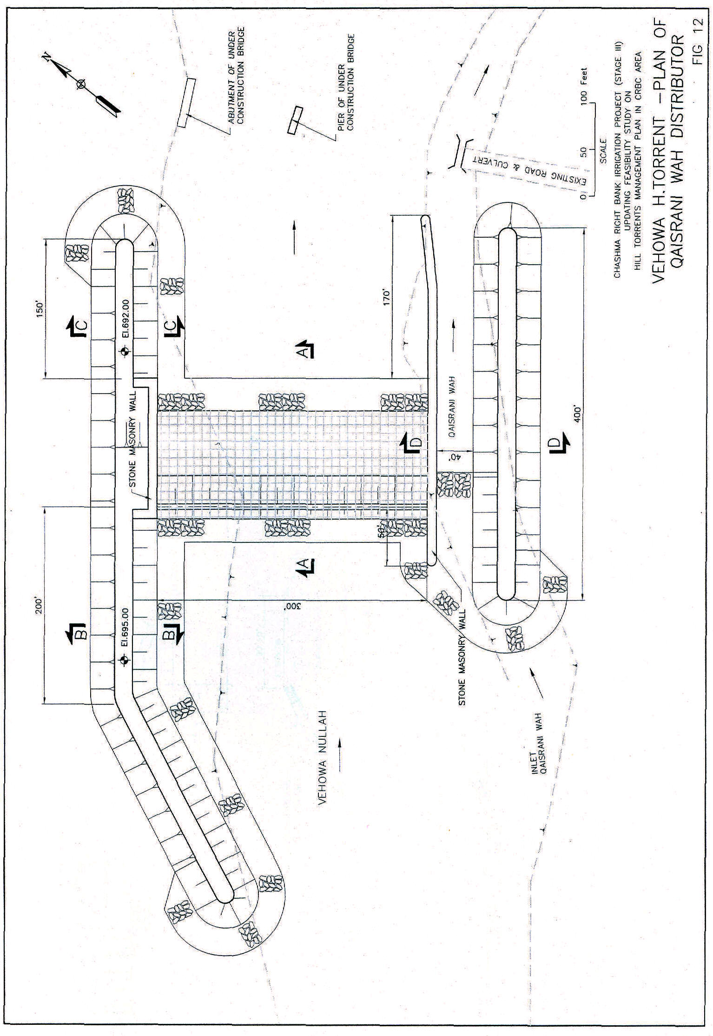

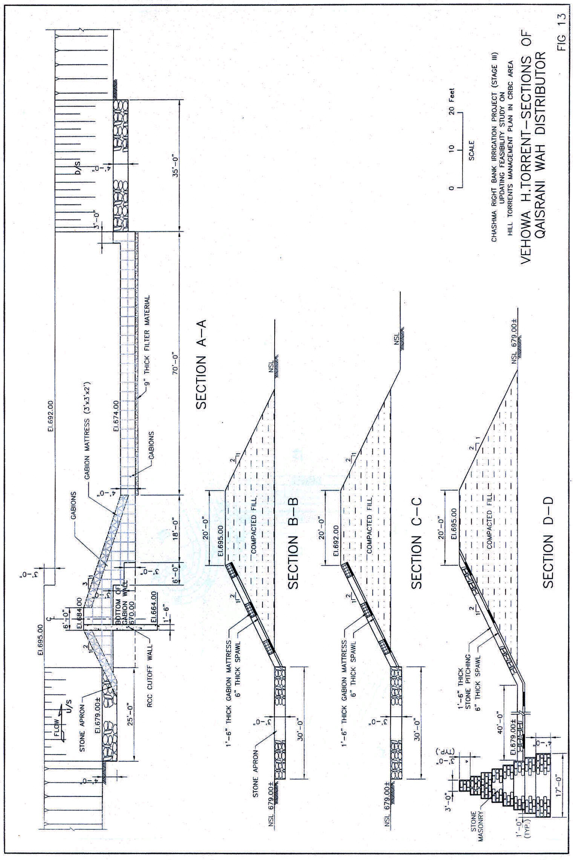
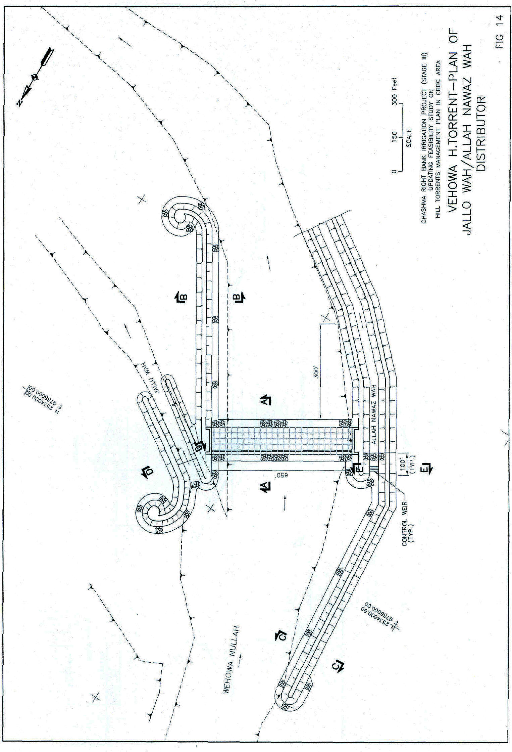
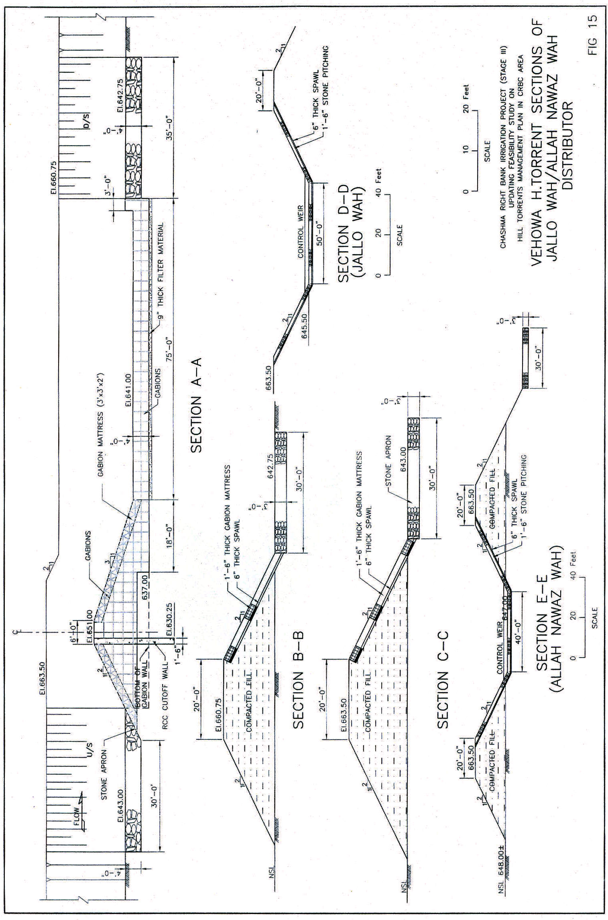
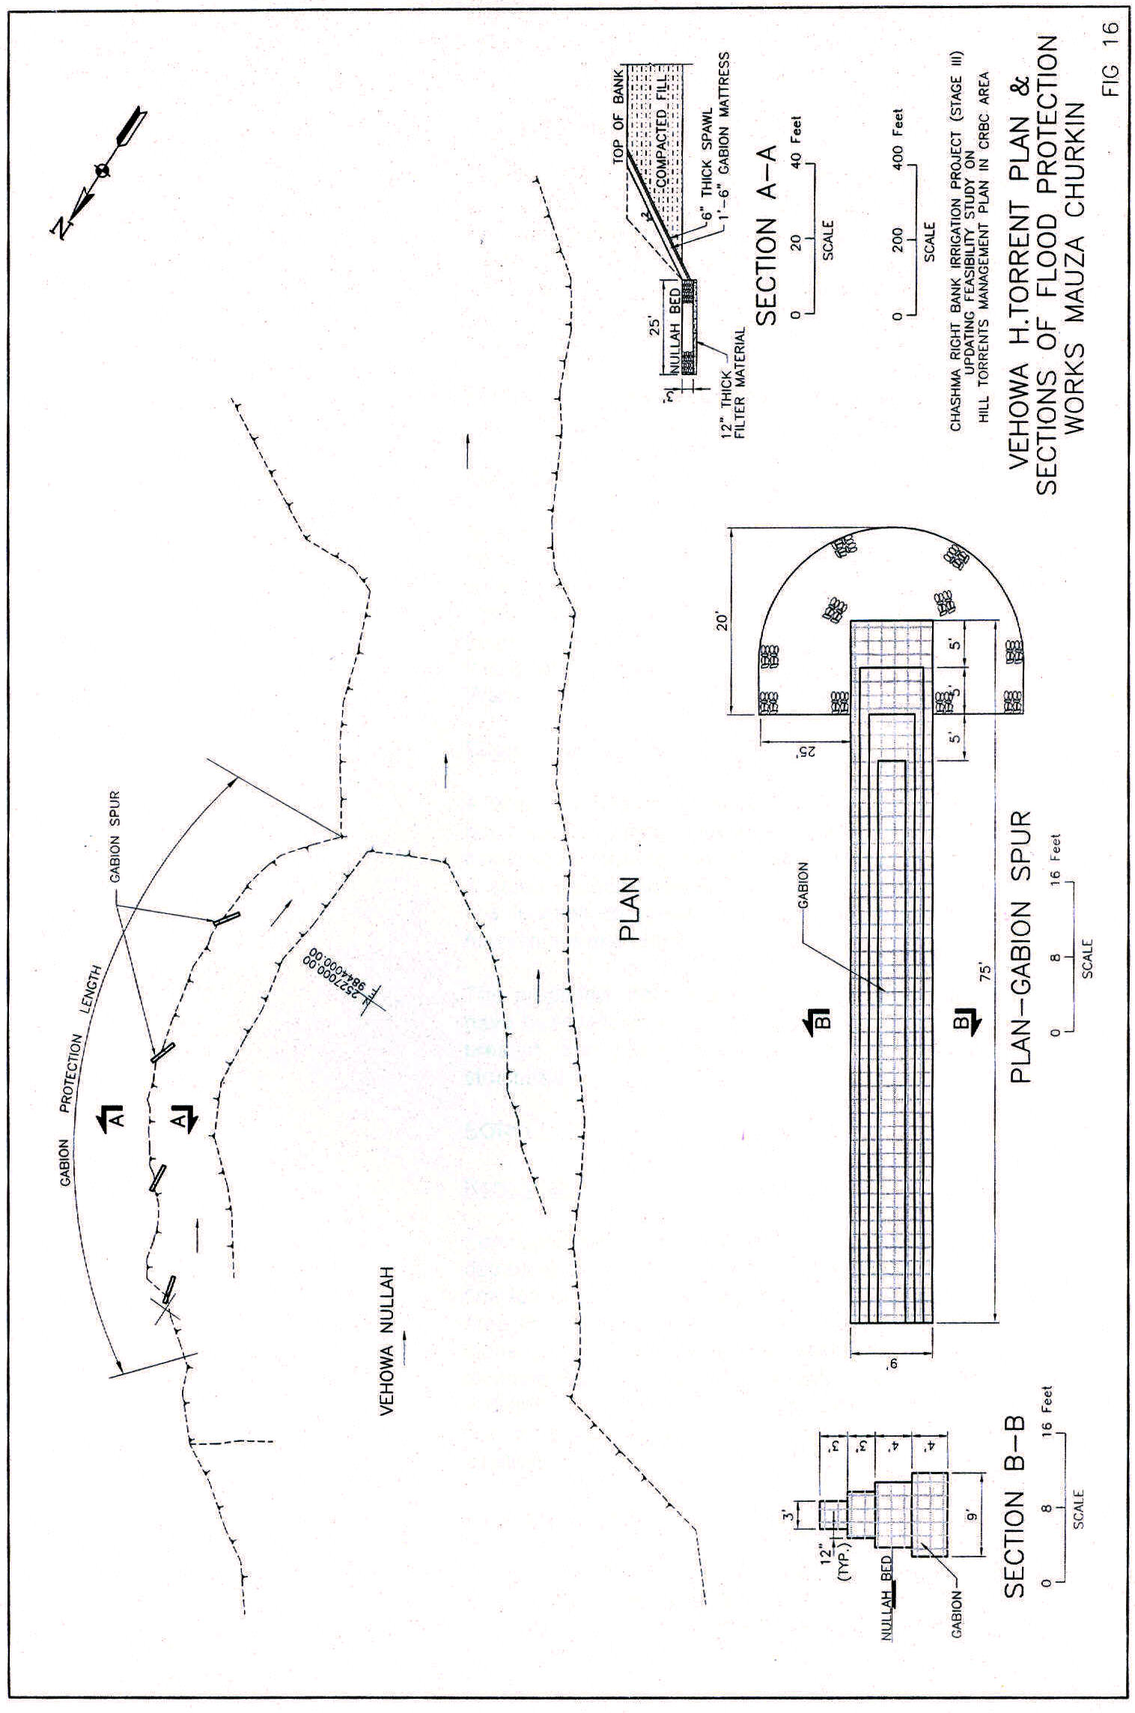
Baghwari Wah

Shakh Janubi flows down its offtake past Mundrani village right side of Sanghar main stream. It flows further for a long distance upto Sokar village. About 4 kilometers upstream of Sokar, Baghwari Wah offtakes from left. Baghwari Wah has a considerable area in its common for which a distributor has been proposed at this bifurcation.

Further down the wah crosses Taunsa Sokar Road, CRBC and Indus Super Highway, on its way to Indus.
Koko Wah

Shakh Shumali of Sanghar Hill Torrent offtakes in a northward direction and flows down to Mangrotha village in a north-eastern direction. Near Mangrotha village, Koko Wah offtakes from left and commands quite a good amount of area. A distributor has been proposed at this location for the delivery of required supplies to the Wah.
Buddo Wah Protection Bund

A little downstream of Mangrotha village, Buddo Wah has receritly (during 2004 flow) developed a creek, short circuiting its route to main stream of Sanghar Hill Torrent. A stone pitched protection bund has been proposed at this location to prevent Buddo Wah (Shakh Shumali) flows to the main torrents.
The proposed structures/works of Sanghar Hill Torrent have been shown on Exhibit 2. Fig. 17 through Fig. 25 present the plans and sections of the proposed structures.
SORI LUND
Rohri Wah

Son Lund hill torrent spreads over a vast area after debouching onto the Pachad plains. Rohri Wah is the first left offtake below Darrah which commands a large area in villages between its offtake point to CRBC. A stone gabion divide wall has been recommended for diverting the Son flows into the wah. The construction of a distributor with a cross weir sounds to be unfeasible due to a very large width of the main torrent at this location.

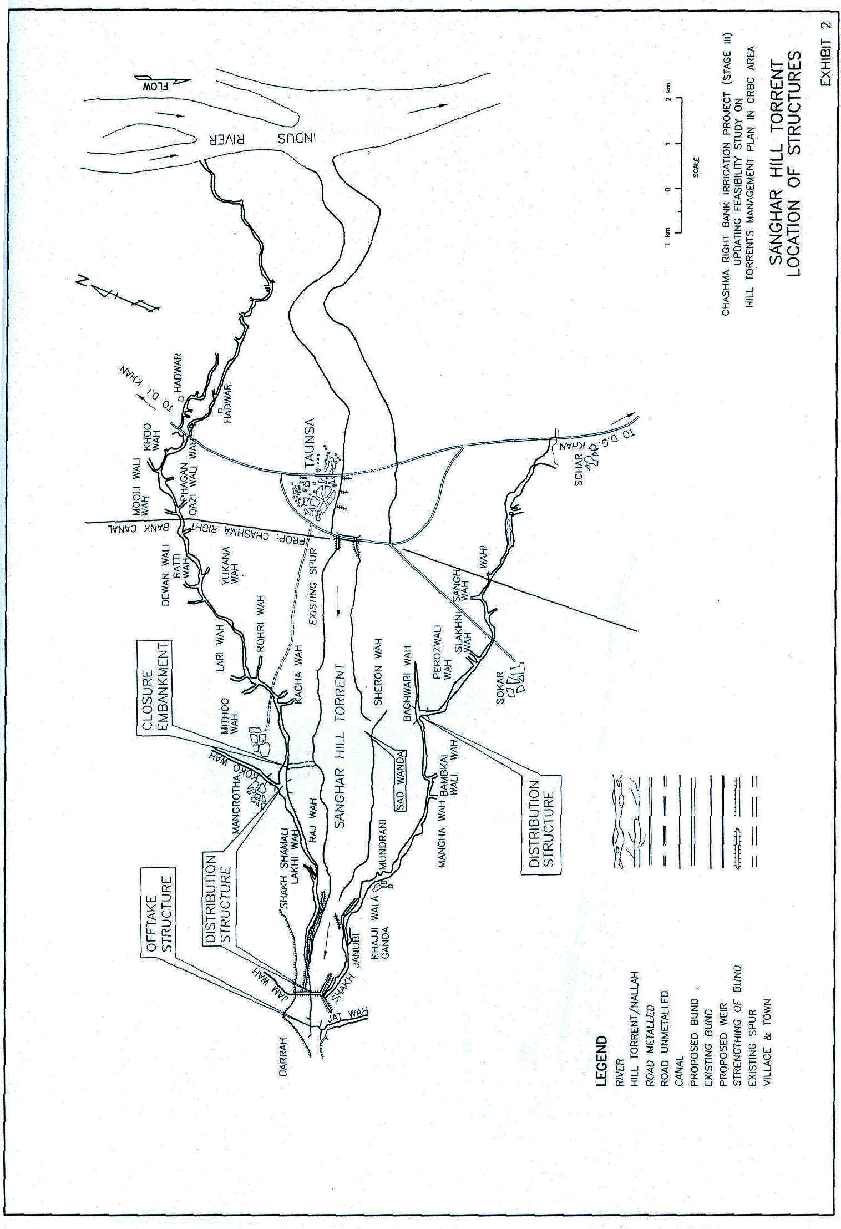

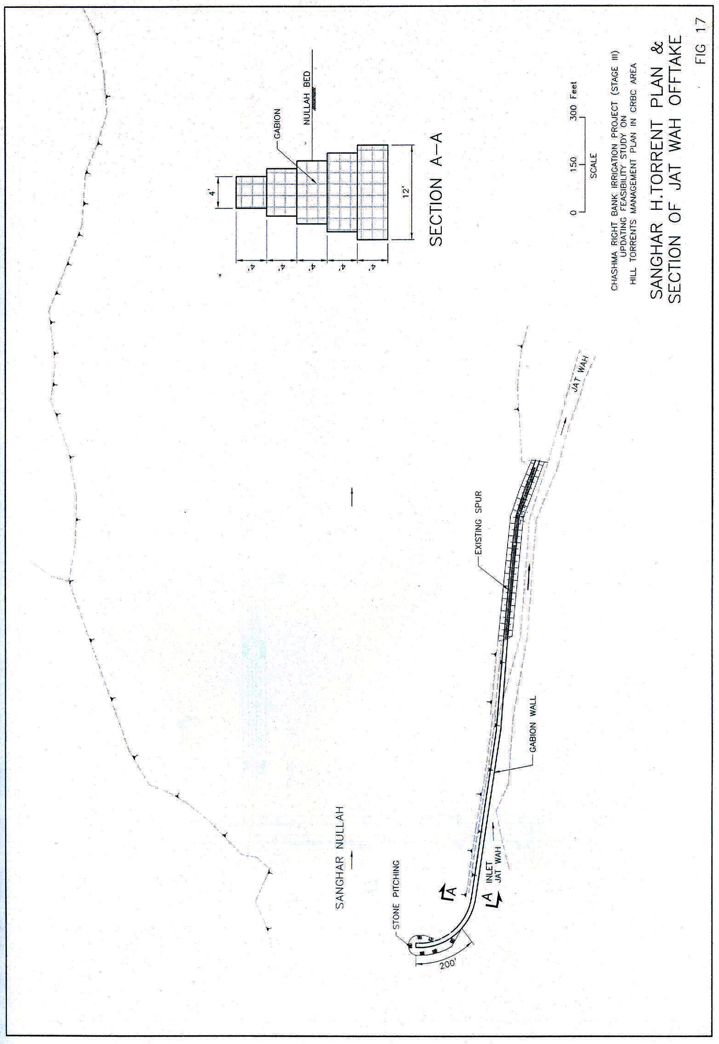

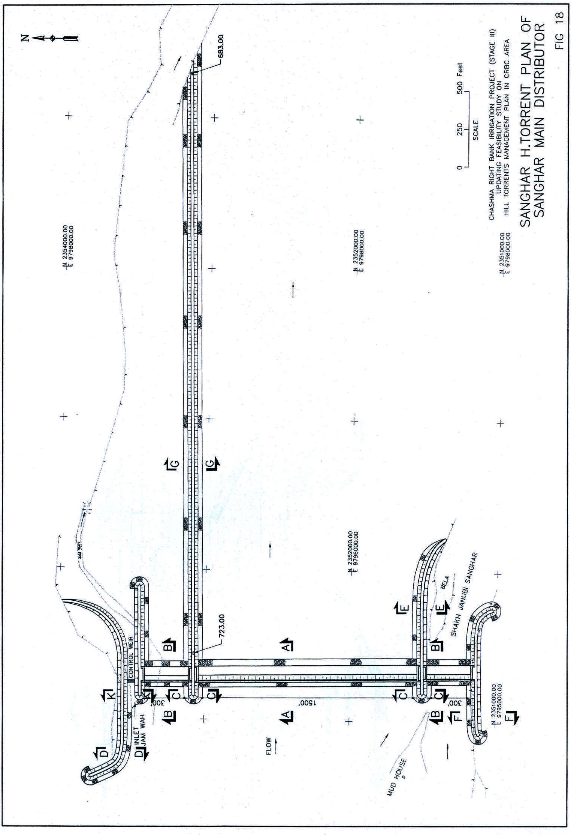

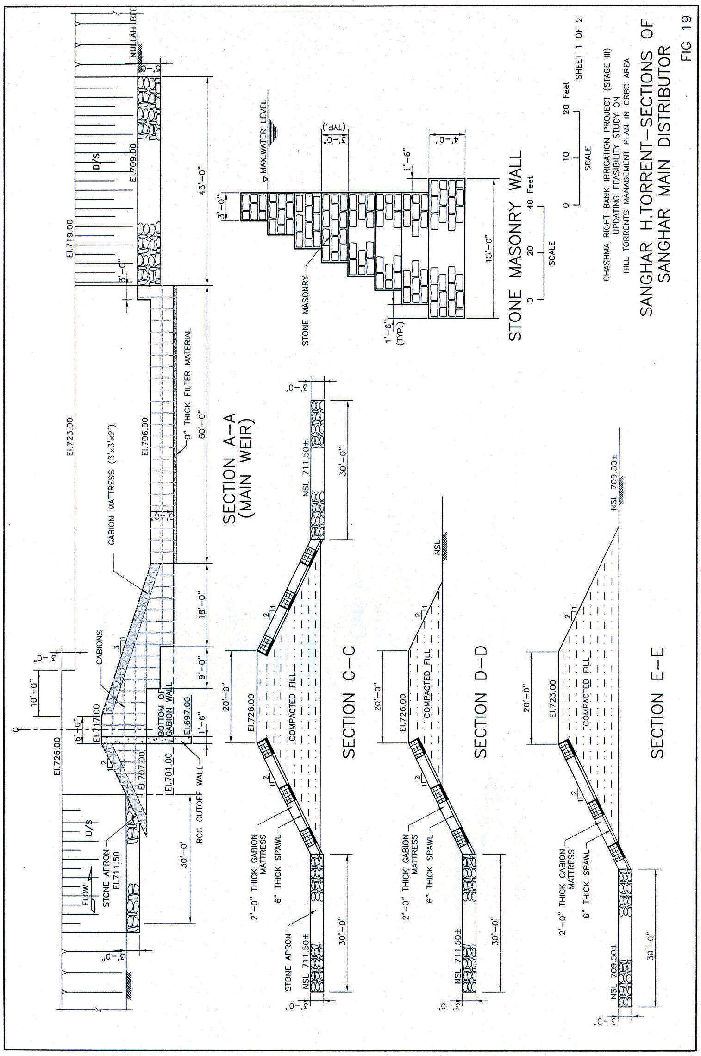
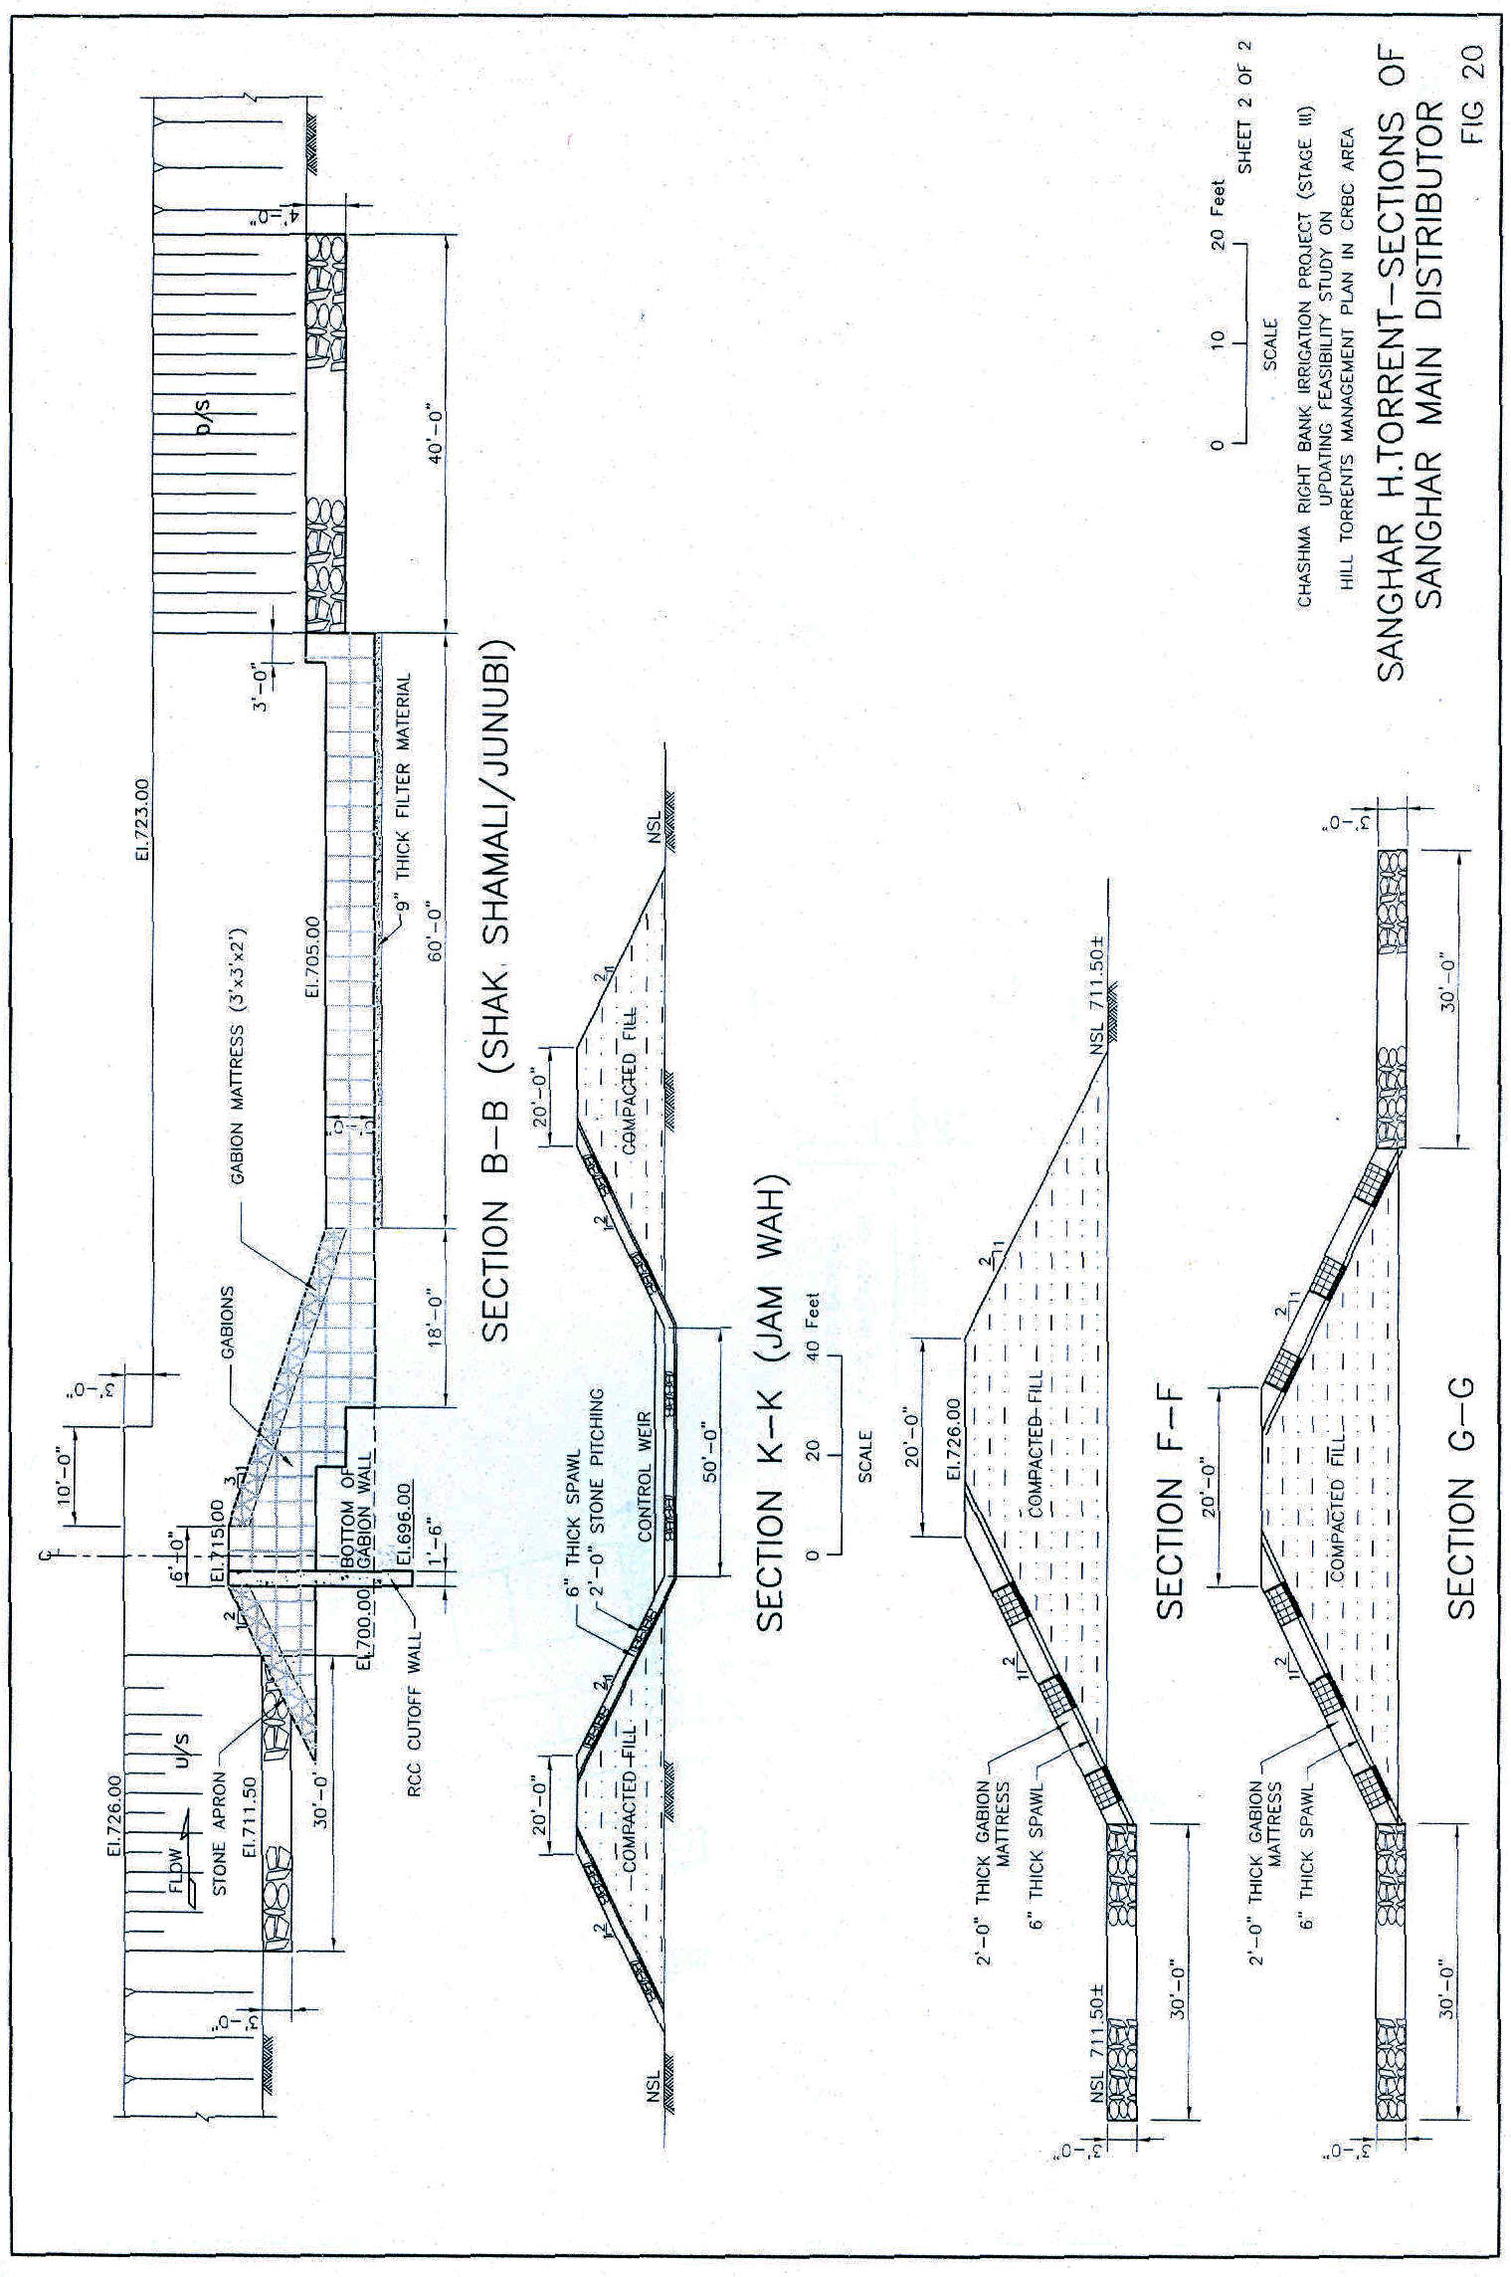
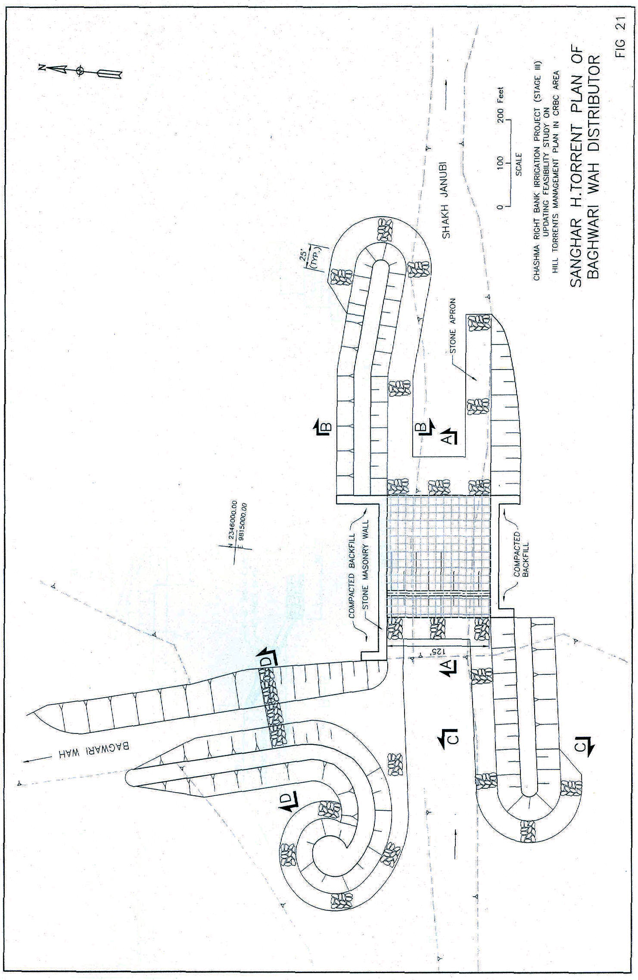
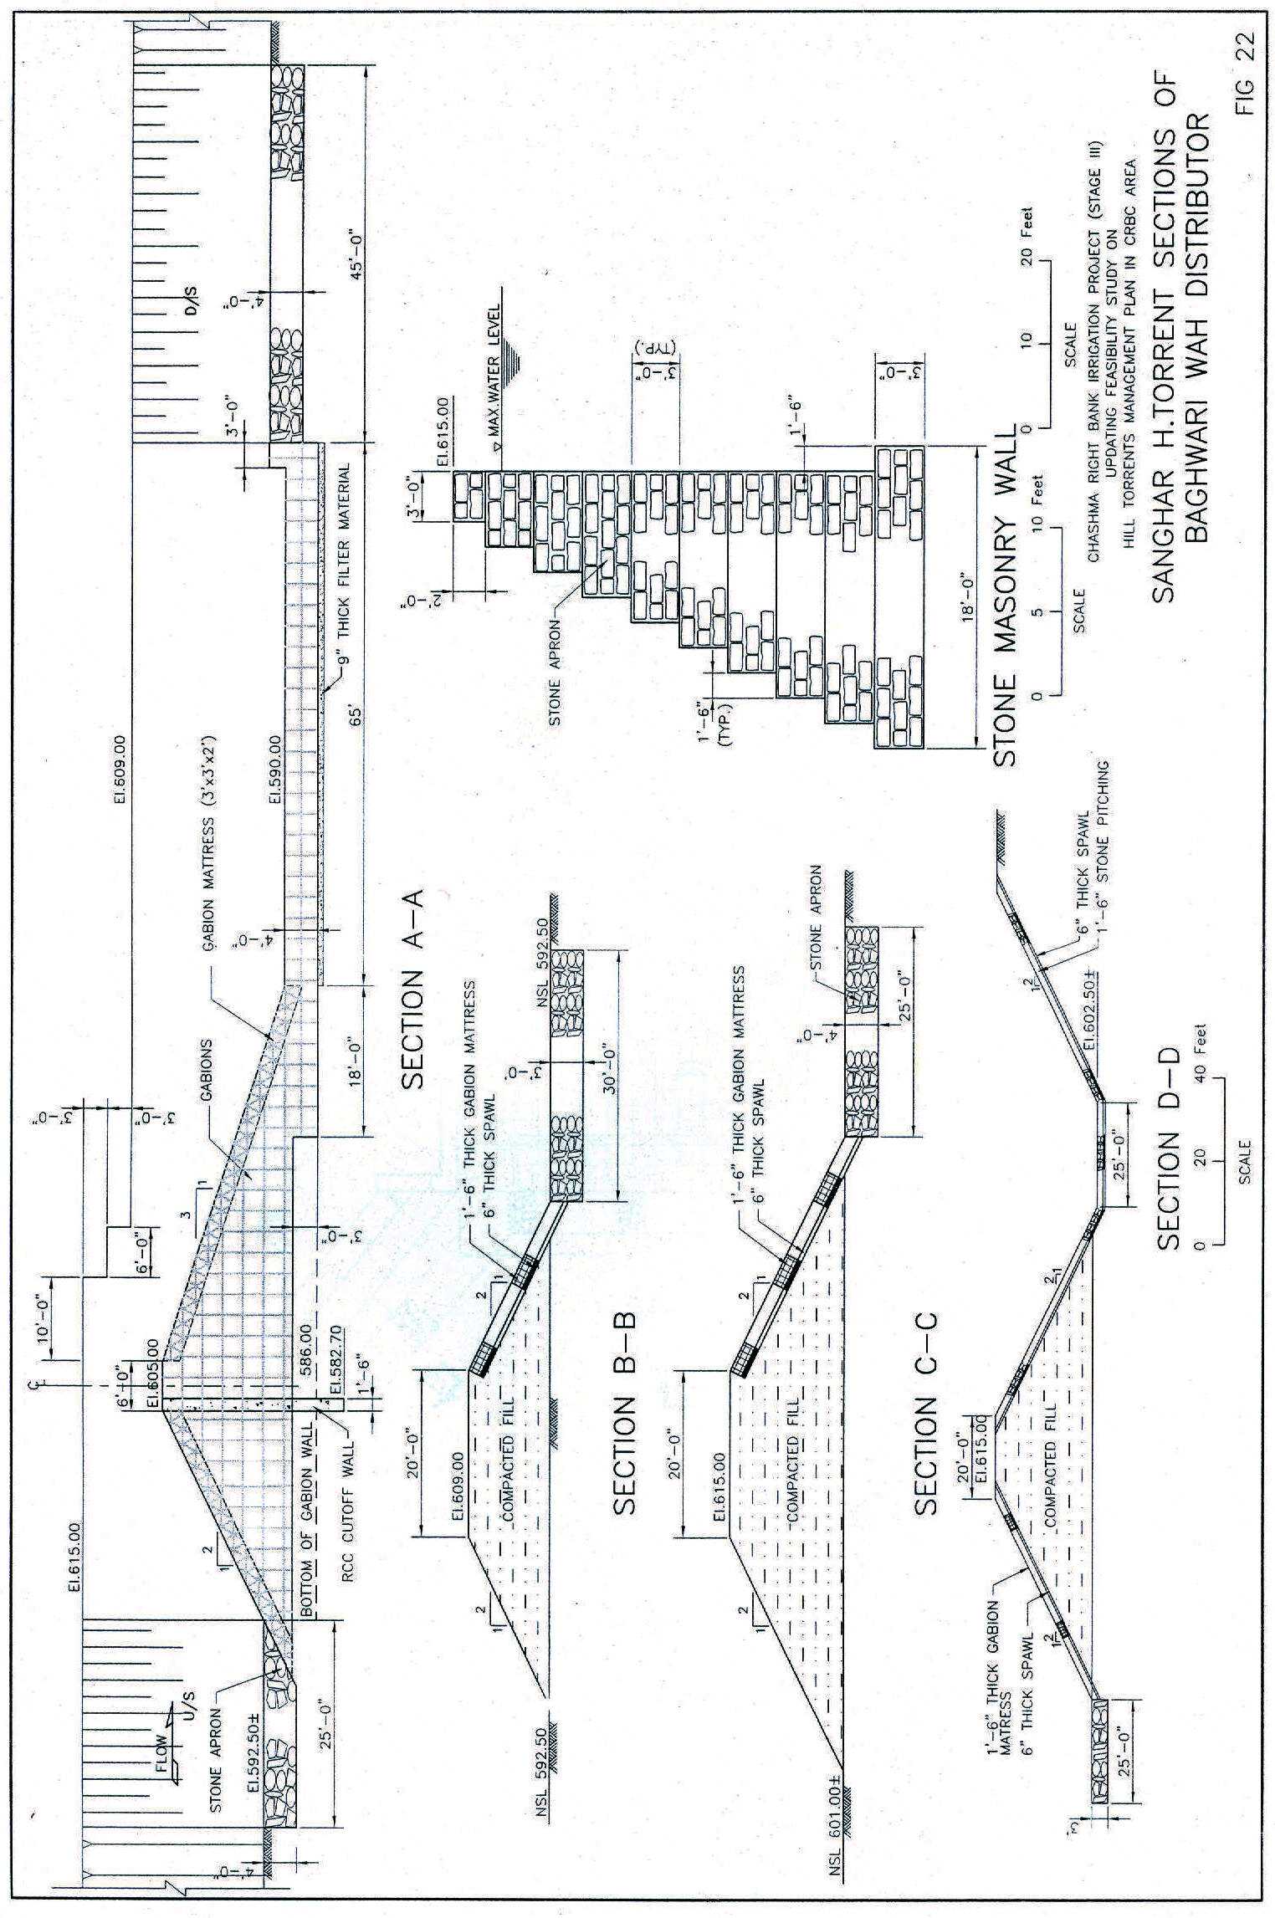
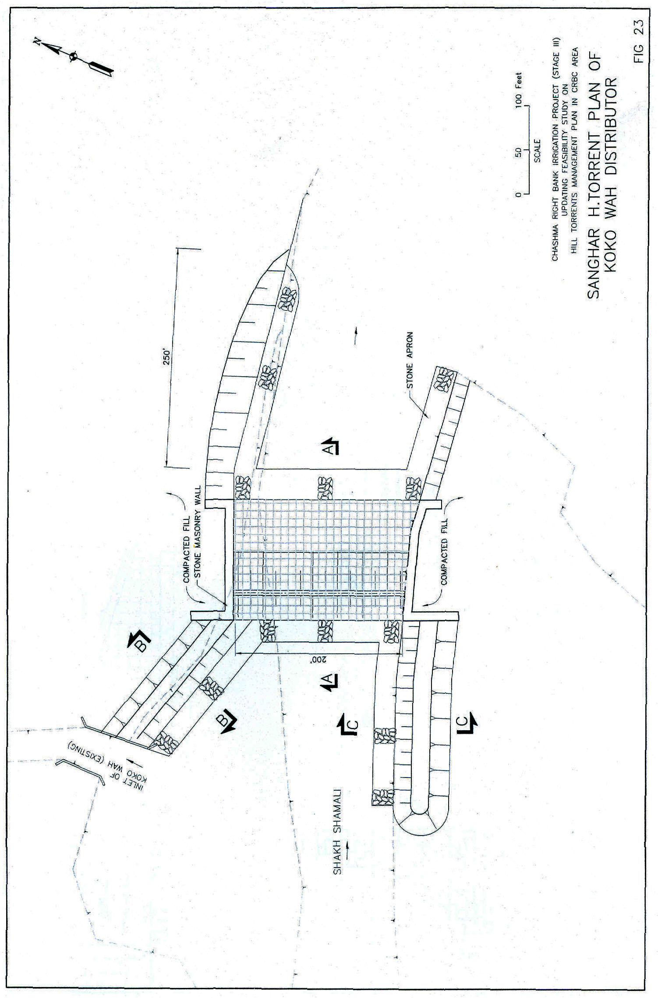
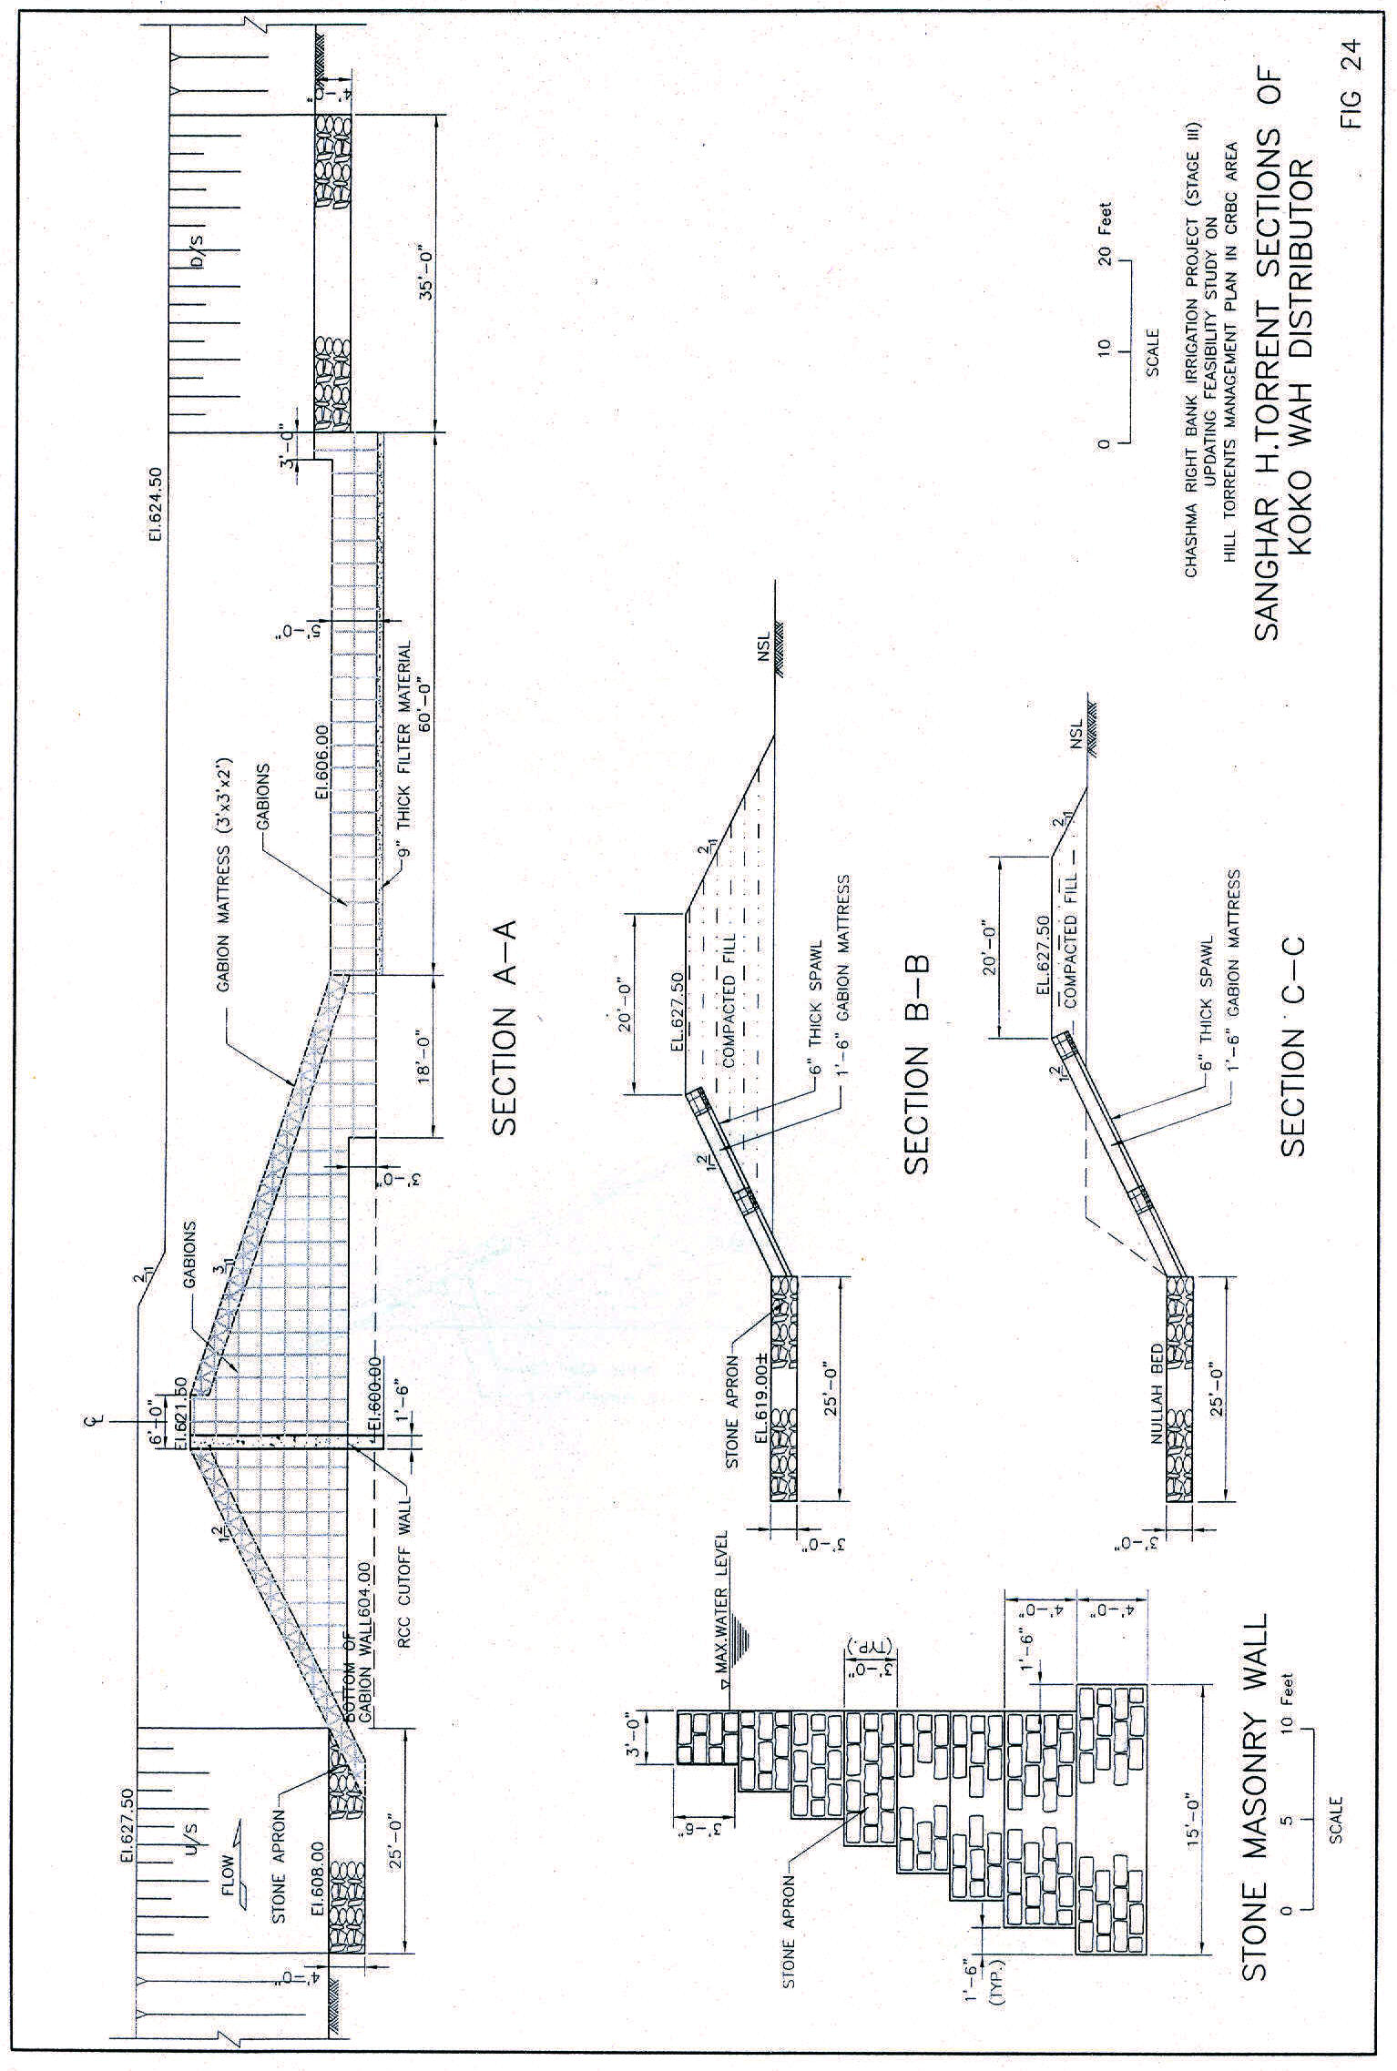
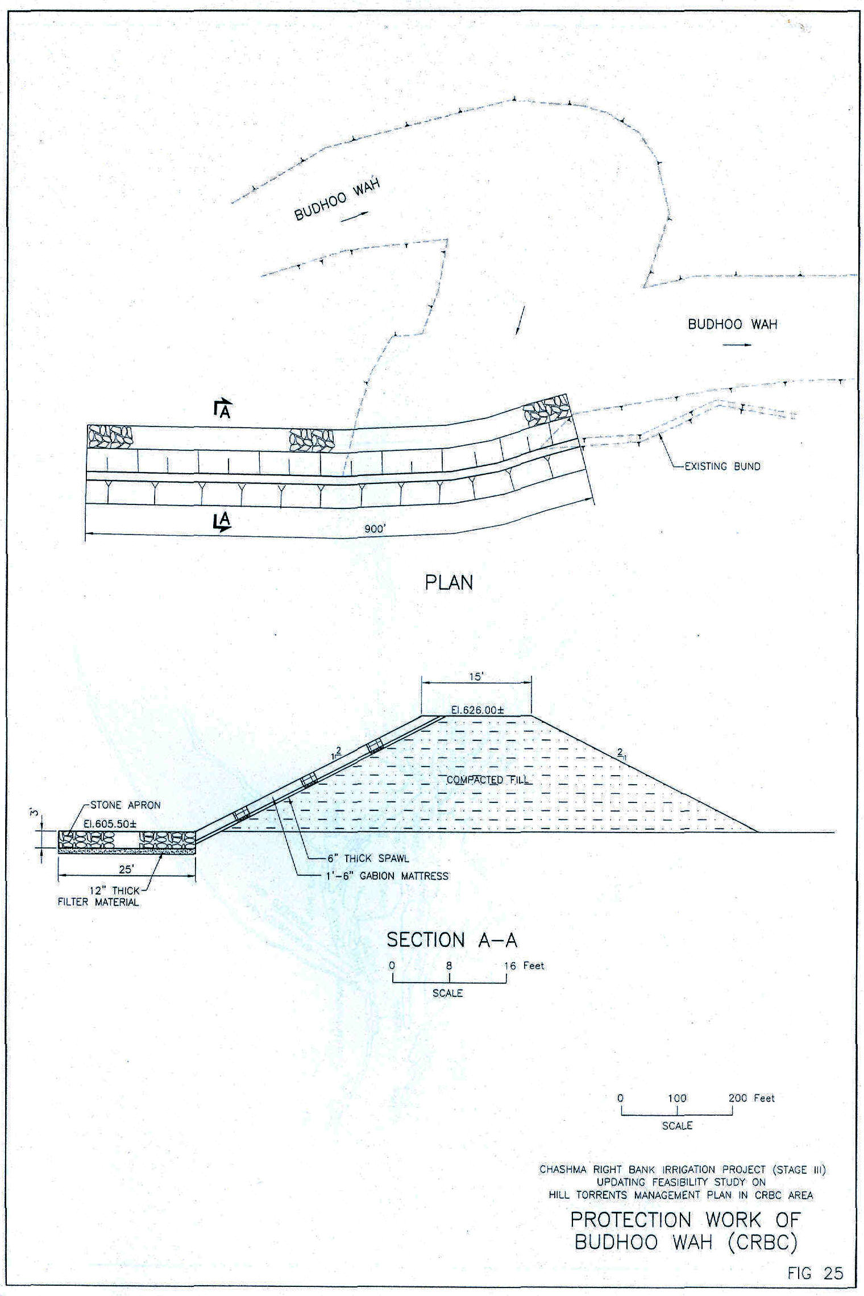
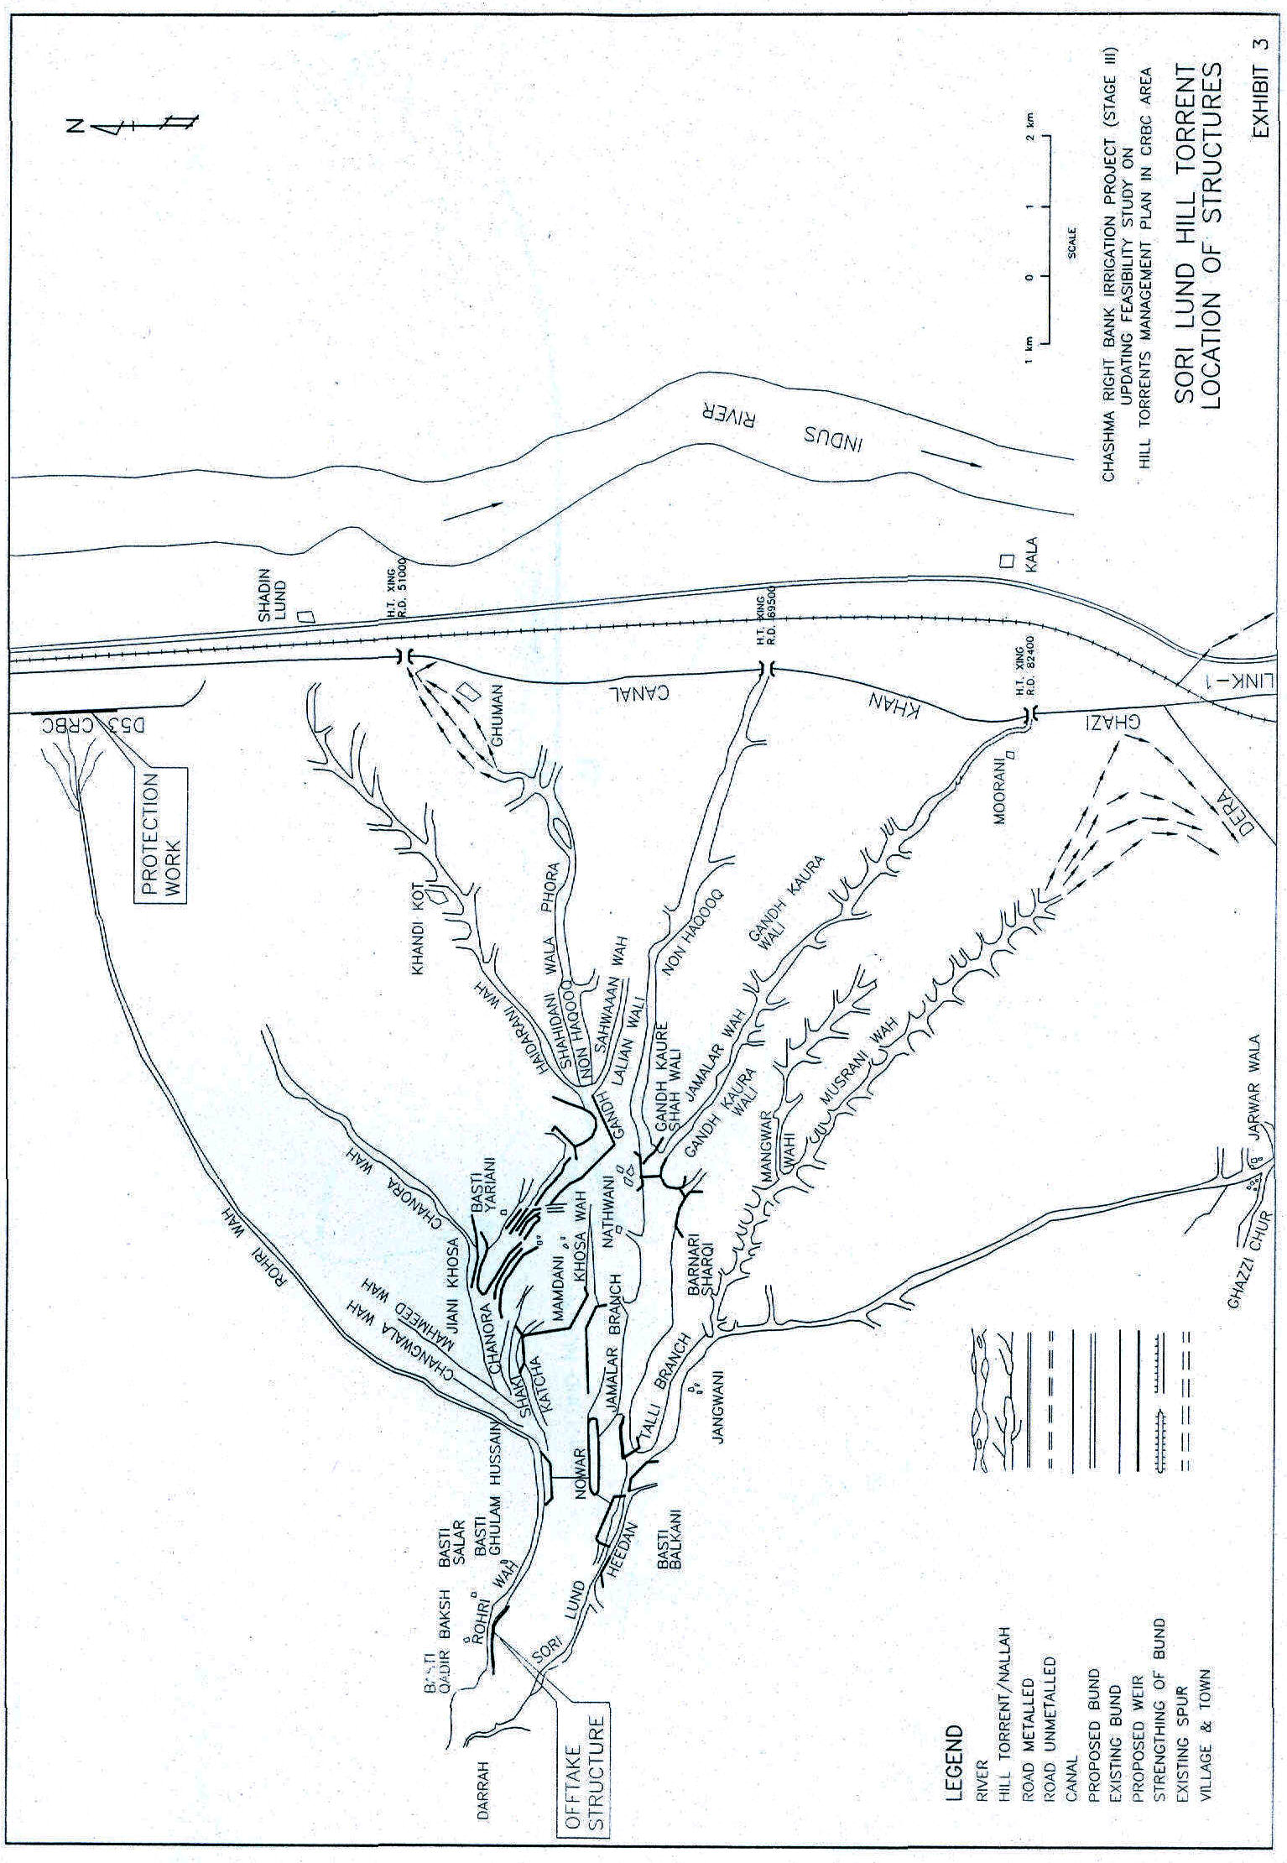
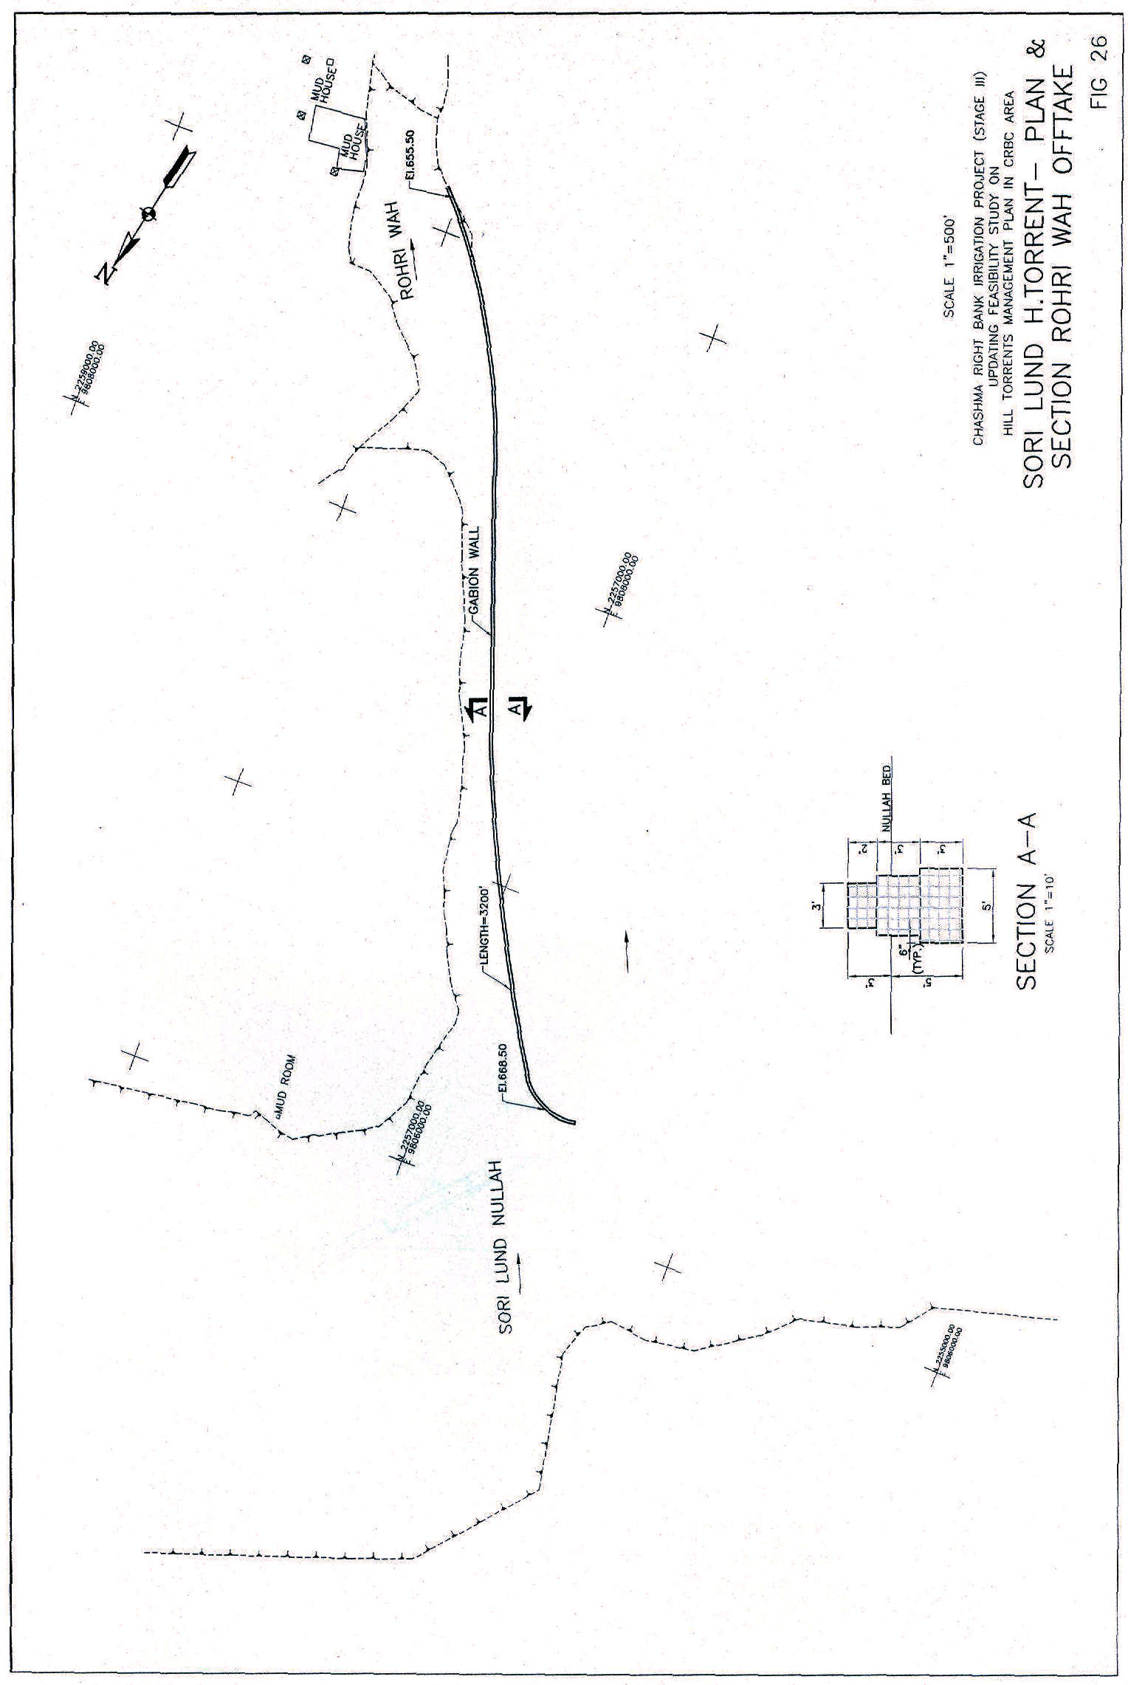
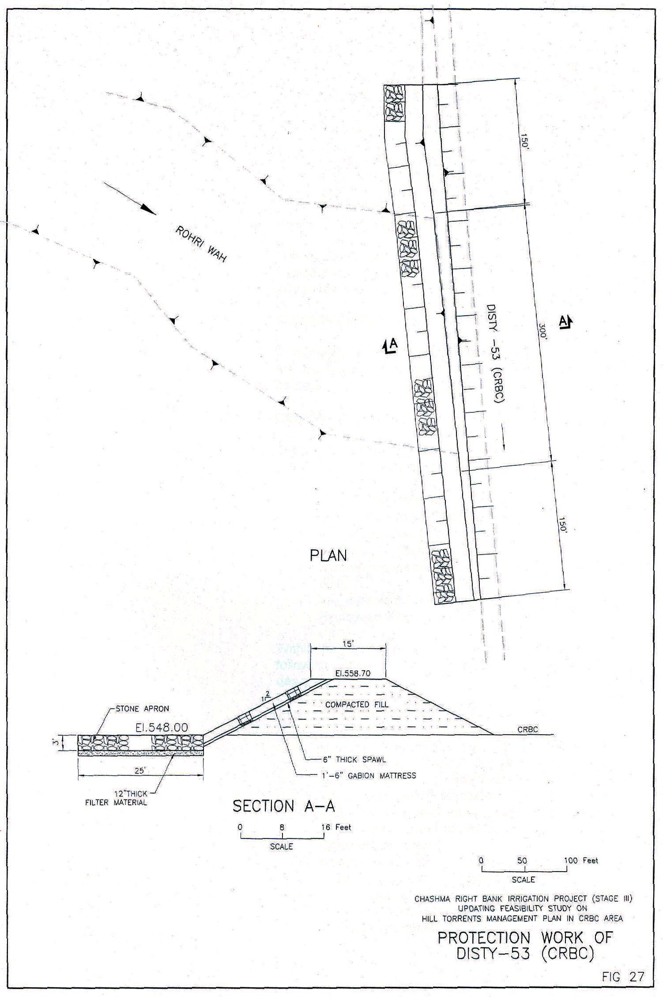
Protection of D-53
In the event of a high flood in Son Lund, large quantities of discharge are delivered into the Rohni Wah. This discharge gets supplemented due to the addition of the surface runoff when it gets ponded against right bank of D-53 of CRBC. Since no cross drainage has been provided at this location, the bank of the distributary gets breached due to the hydraulic pressure of accumulated flood flows. During 2003, a breach was developed downstream of Taunsa-Zind Peer Road Bridge.
The provision of a cross-drainage structure does not sound feasible due to the command area and irrigation distribution system across D-53. Stone protection has been proposed at the vulnerable location of the bank to provide it safety against the flood thrust.

The location of the proposed works has been shown on Exhibit 3 and Fig. 26 through Fig. 27 present the plans and sections of the proposed structures.
SUMMARY OF PROPOSED STRUCTURES/WORKS

A summary of the structural measures provided within the framework of recommended plan is presented in Table 2.
DESIGN CRITERIA

The design of all the structures has been based upon the following main principles:

• Use of local materials,
• Minimum or no land acquisition,
• Use of Local unskilled labour might,
• Environment friendly design,
• Maximum possible output with minimum (optimal) cost,
• Improvements as suggested by the “Impact Evaluation Study of Kaha Hill Torrent”.
Within the framework of above mentioned principles, the following main criteria have been adopted while designing the structures:
• All the structures are flexible, comprising gabions in wire crates.
• Hydraulic designing of weirs have been carried out using the ‘Manual for Design of Flexible Gabion Structures in Rivers and Stream Training Works’ prepared by Maccaferri.
• Water levels in the torrent are calculated using HEC RAS computer model, prepared by US Army Corps of Engineers.
• All the gabion weirs are glacis type with upstream slope IV:2H and downstream slope lV:3H.
• A 2 ft gabion mattress has been provided on upstream and downstream glacis of all the diversion structures.
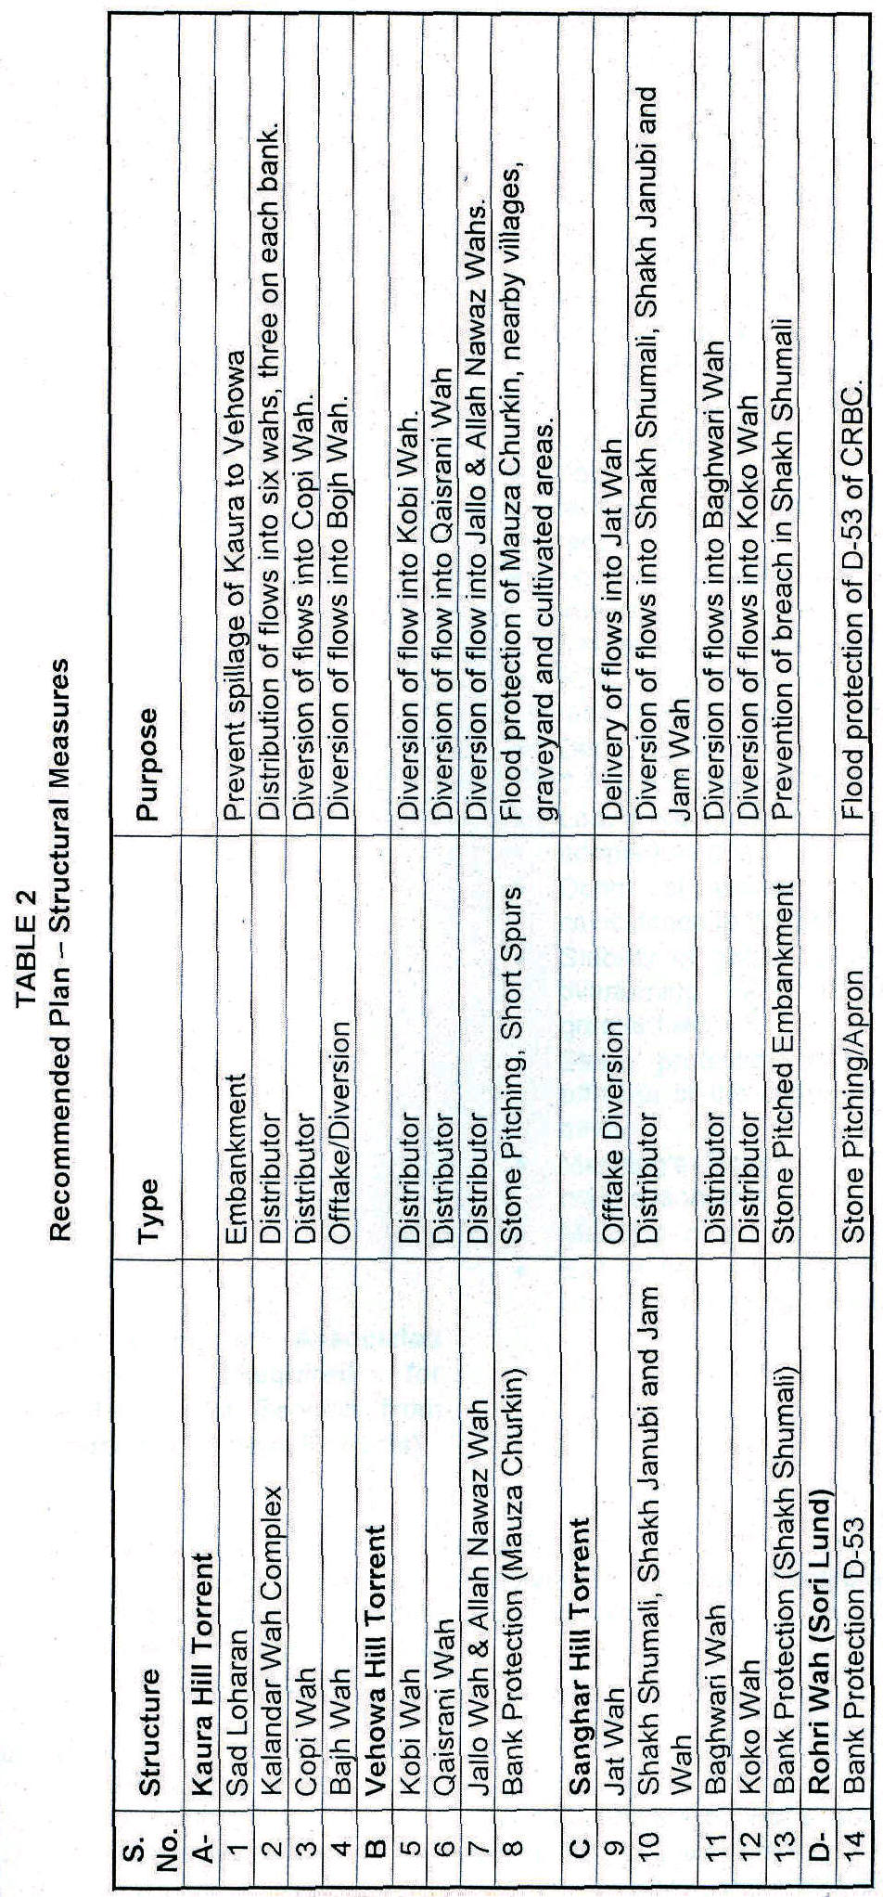
- All the weirs have been provided vertical gabion walls on both banks.
• Top width of crest of all the weirs is 6 feet.
• The stilling basins have been sized to cover all ranges of discharge.
• The bottom of the stilling basins of all the diversion weirs have been provided with 9” thick filter of coarse material.
• For all the structures, upstream and downstream guide bunds have been provided with gabion protection and apron.
• Top of the crest of the weirs has been fixed at a 5-year discharge.
• Top of embanks/walls are designed at a water level of 25-year discharge with a free board of 3 feet.
• Top of embankments/walls have been checked against a discharge of 50-year return period. It has been found extra-safe.
• RCC cut-off wall has been provided to all the main (cross) weirs at upstream side of crest.
• Depth of cut-off is provided using safety factor of 1.5 R, R being the scour depth.
• Lacy’s silt factor for scour depth calculation is adopted as one ‘1’ (f=1.0)
• Depth of gabion wall has been kept in-coincidence to the bottom level of stilling basin.
• Stability of gabion walls has been checked for overturning. Factor of safety for overturning is greater than 1.5.
• Stone protection has been provided to the offtakes of the channels in a length of 100 feet each.
• Manning’s Roughness Coefficient (n) used for main channels is 0.035.
• Manning ‘n’ used for channels is 0.030.
• Exiting bed slopes of the channels have been used for designing the channel offtakes.
15. Description of Associated Measures (Required for Realization of Benefits from Irrigation/Drainage Projects)
(a) Public Sector
- Colonization | Not Required
- Agricultural Extension | Required for inception of improved agricultural practices.
- Communication (indicate whether included in this or some other Project) | Not Required
(b) Action by Farmers or other Agencies e.g.
i) Construction of Watercourses | The maintenance of ‘wahs’ and watercourses is already being done by the farmers.
ii) Improved Practices etc. | Improved practices and inputs are required.
16. Arrangements for Implementation of Projects
a) Administrative Arrangements
16.1 Executing Agency | The Irrigation and Power Department (IPO) of the Government of Punjab Province (GOP) will be executing agency for the implementation of Project’s planned structures/works. IPD will be responsible for Detailed Design and Construction of structures/works in the Project area. A senior officer of IPD will be appointed as Project Director.
16.2 Consultants | In order to undertake detailed designs of proposed structures/works, preparation of tender documents, prequalification of contractor’s evaluation of contractors bids, award of the Projects to Contractors, construction supervision, processing of contractor’s bills, final checks and preparation of completion reports, IPO will engage local consultants having practical and long term association and experience in the field of flood management of hill torrents. An experienced engineer will lead the Consultant’s team as Project Manager.
16.3 lmplementation Schedule | Starting from the date of start of implementation, the Project will be completed within a period of about three years. A tentative the initial year will be utilized to:
• prepare the detailed designs,
• set up the beneficiaries’ participatory organizations including social mobilization and preparedness campaigns,
• Land acquisition, if required
• Prequalifications and award of project.
• Setting up of site offices
• Mobilization of Contractors, and
• Construction supervision.
 | During the next two years, construction of structures/works, supervision, processing of bills, preparation of completion reports and other related activities shall be continued and completed. A tentative implementation schedule of major activities is attached as Fig. 28.
(b) Availability of Contractors | The contractors are available in and around the project area, province and the country.
(c) Other Relevant Information | The construction of works of the project shall be managed by IPD with the assistance of supervising consultants, prior to execution of project, detailed design will be carried out by the Consultants.
17. Land Acquisition/Crop Compensation and Resettlement
- Land Acquisition  i) Area  ii) Cost | In general and acquisition/crop compensation requirement has not been foreseen. Efforts have been made to undertake the layout of the structures over government lands. The farmers of the area are also willing to donate the land for Project structures if required.
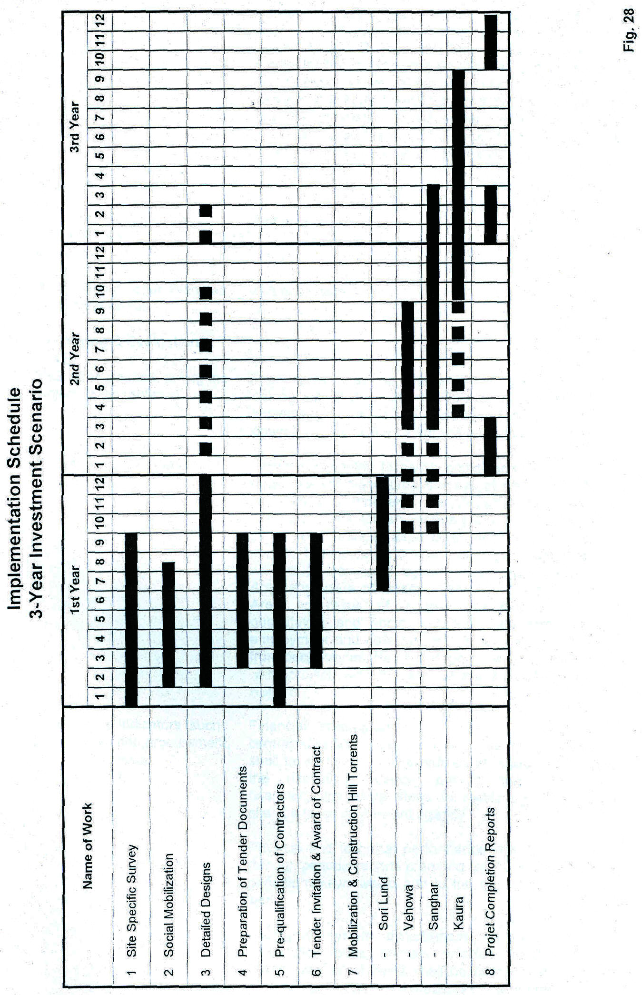
 | However, a lump sum provision of Rs. five million in the Project has been made to meet the incidental needs if required. The formal legal agreements with farmers, regarding free of cost donation of land and without crop compensation for the proposed structures may be undertaken during social mobilization process. Anyhow, the land acquisition process may be completed during the first year of the Project activities.
- Resettlement | Resettlement is nor foreseen
i) No. of families to be resettled  ii) Cost | Not applicable
(c) Resettlement Action Plan has been done or not | Not applicable
18. Monitoring and Evaluation (M&E)
(a) M&E arrangements during the project implementation | Procedures shall be prepared immediately after setting up of Consultant’s Project Office (field) implemented accordingly. Arrangements shall be down in the Consultant’s Agreement with IPD.
(b) M&E arrangements after completion | Within six months following completion of the project, additional socio-economic surveys of the representative sub-projects completed under the programme shall be carried out to establish various parameters on physical, social and financial aspects to determine the project impact. The indicators of financial and economic benefits will include increase in agricultural production in Pachad Area and value of losses averted in Canal Command Area as result of project implementation. Other quantitative and social indicators are farm income, employment and collection of agricultural income taxes from beneficiaries. Results of the socio-economic survey ‘with project’ will form part of the Project Completion Reports.
(c) Performance Indicators (such as disbursement, procurement, physical, technical environmental) | Financial accomplishments in terms of amounts of contracts/packages awarded and level of disbursement shall be monitored and evaluated at regular intervals by the executing agency, project consultants, and financiers. Immediate steps to rectify the deficiencies shall be taken by relevant agency.
 | Physical and technical performance shall be monitored through periodic reports prepared for the Project. Special periodic reviews would add to the quality and speed of work.
 | Ecological system disturbances relating to human inhabitation, birds, animals, wildlife, vegetative cover, canopy and other items shall be continuously watched and necessary corrective measures shall be taken.

19. Agricultural Benefits of the Project
(a) Crop Benefits
i) Increase in Cropped Area | Proper management of hill torrents supplies will raise the existing low cropping intensities. Flood flows are planned to be managed for the development of cultivable areas and to avoid losses in CRBC canal command area.
 | ‘With Project’ increase anticipated in the cropped area against 25-year design floods is as below:
 | 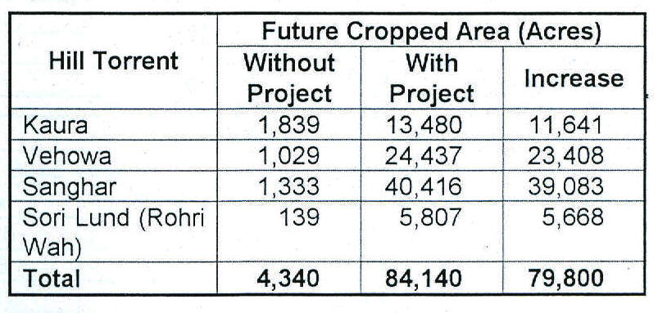
ii) Increase in Yields | It is anticipated that most of the project agricultural benefits would in cropping intensities. However, manageable flood water supply would also bring improvement in cultural practices and input utilization resulting in increase in crop yields.
iii) Increase in total output | The aggregate output shall comprise almost 80,000 acres of cropped area, 23,000 tons of production of various crops, employment of farm labour and all intangible direct and indirect benefits. The improvement in cropping pattern and production with project, management of hill torrents against design floods is given in Table 3.
iv) Change in Cropping Pattern | Of the total culturable command area (CCA) of 116,385, the existing cropped area has been reported to be 13,520 acres (11.6%). The future anticipated cropped area under ‘without project’ conditions amounts to be 4,340 acres against 25 year flood. In the project areas, agricultural production mainly depends on the availability of flood flows during rainy season, thus, drought resistant crops like millet, pulses, oilseed and wheat are generally sown.
 | Under ‘without’ Project condition, the cropped area decreases as the flood increases. This is due to inefficient diversion works built by the farmers. As the torrent flows increase, the diversion works get breached, the water is wasted and the cropped area decreases. It decreases from about 11.6% to only 3.7 percent, as the flood increases from 2.33% level to 25-Year. On the other hand, under with project condition, the cropped area increases as the flood increases. It gets enhanced from 3.7 percent to 72.3 percent against 25-year flood.
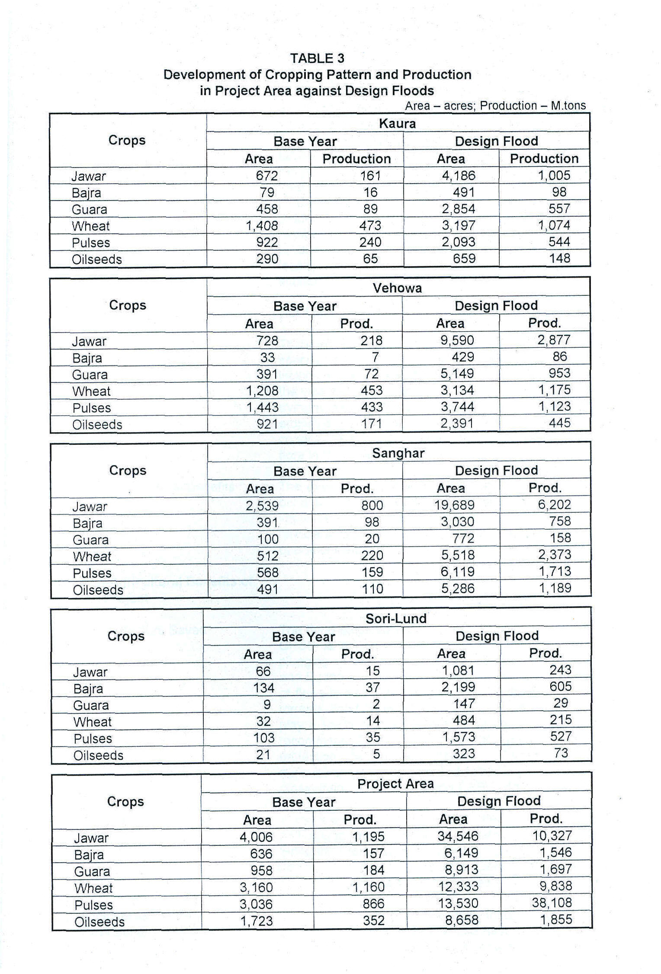
(b) Livestock Benefits | In the Project area, livestock generally includes cattle, buffalo, cow, goat and sheep. Agriculture in the area, by and large, also depends on draught animals for construction of bunds, ploughing and catering. Major part of livestock is reared by nomadic and transmuting families, deriving 60-70 percent of their feed from the ranges and the remaining 30 percent from the cropped area. The Project, on completion, will increase the cropped area which will be able to provide nutrition fodder in greater quantities thereby improving the number and quality of livestock in the area. The livestock production being the second largest profession of the locals, would play a considerable role in the uplift of their economy.
(c) Fisheries (where relevant) | Not Applicable

(d) Forestry, Agro/Social Forestry (where relevant) | There are no regular forests in the area. However, it has specific ecologic elements. Terrestrial plant species, including trees, herbs and shrubs are sparsely found in the vast dry lands and hilly catchment. Some farmers are trying to develop forests on their uncultivated lands. The project works are expected to improve the groundwater condition which will enhance the forest production and flora in the area.
(e) Other Agricultural Benefits | The expected increase in the availability of water would bring several indirect benefits to agriculture sector e.g. improved farm practices, use of improved seeds and fertilizers, addition of new crops, and improved farm operations etc.
20. Non-Agricultural Benefits of the Project
- Infra-Structure Saved | The flood protection of Churkin Village area and D-53 of CRBC is a part and parcel of the Project area. The plugging of the creek of Kaura Hill Torrent to Vehowa arid Buddo wah to Shakh Sumali to prevent the wastage of flows is also a part of the Project Plan. The use of hill torrents flood flows for agriculture is also expected to play a key role in the mitigation of flood damages. The recommended plan is thus designed to provide protection to houses, roads, irrigation channels, agricultural lands, electric and telephone lines, bridges, cross-drainage structures and CRBC command area.
(b) Improvement in Health Conditions | In the areas vulnerable to flood speedy reproduction of pathogenic micro-organisms creates health hazards. Since the Project is to designed to mitigate the effects of floods, flood protection being a special component, this hazard is expected to be minimized.
(c) Improvement in Regional Environment | The Project studies included Initial Environmental Examination (lEE) studies. These have been carried out in line with the AOB guidelines, whereby the Project is anticipated to have a grossly positive environmental impact. Direct effects of the Project include safety of land against erosion, increase in cultivated area and crop productions, uplift of socio-economic environment, social confidence, prevention of floods and health hazards, improvement in ecological environments, increase in job opportunities for farm labour, improvement in groundwater table, development of livestock etc.
 | The study indicated that of the 35 key environmental parameters, 13 have shown considerable positive impacts, 12 remained unaffected and three have minor to moderate negative effects for which appropriate modifications have been incorporated in the project implementation procedures and designs.
(d) Other Non-Agricultural Benefits | The considerable non-agricultural benefits, include flood protection of:
i- Crops
ii- Private houses
iii- Road
iv- Prevention other direct damages
v- Prevention of indirect damages.
 | The Project studies have indicated that the aggregate average annual damages in these sectors are about Rs. 73 million, against 25-years flood. The implementation of the Project works would save the average annual damages of about Rs. 18 million.
The intangible benefits include:

• the building up of the social confidence due to raised income
• uplift of the social activities including youth and women
• increase in demand of better amenities of life
• increase in farm output trade
• prevention of health hazards
• reduction in social disputes due to useful activities
• development in social sectors e.g. education, politics etc.
• creation of employment opportunities during a post construction period.
21. Environmental Aspect
Detailed sector-wise information on environmental impact assessment and its mitigation should be provided. All projects require an initial environmental examination. If necessary, this is followed by a more detailed environmental impact assessment. Where there are adverse impacts resulting from the project, a fully costed program for their mitigation is required. The cost mitigation should be included in the projects costs for the purpose of economic analysis. Quantifiable positive impacts should be included in the projects benefits when doing economic evaluation of the project. | No adverse environmental effects are, in general, envisaged as explained in 20 (c) above. On the contrary the works included in the project would help in protecting environmental hazards such as degradation of the land by inundation and erosion etc.  The positive environmental impacts on physical, ecological and socio-economic issues result in sustainable development in the region. It is concluded that there is no need for any further environmental study on project like EIA.
22. Facilities to be provided by the Project
(a) Special Facilities (such as roads, hospitals, tubewells, drains, channels, command area, tractors etc.) which will become available to the people of the Project area. | No special facilities required
(b) Other Socio-Economic Benefits/Disadvantages which are likely to accrue as a result of the Project. | Construction of Project works is expected to utilized public/government lands. Most of the expected beneficiaries are willing to donate their land free of cost if required. However, in order to cater the situation of any beneficiaries promise-deviation, adequate provision of funds for acquisition of land has been made in the Project cost. In addition, no other appreciable loss is anticipated at this stage.
23. Summary of Capital Costs (Rs. Million) | Summary of the cost is as follows:
 | 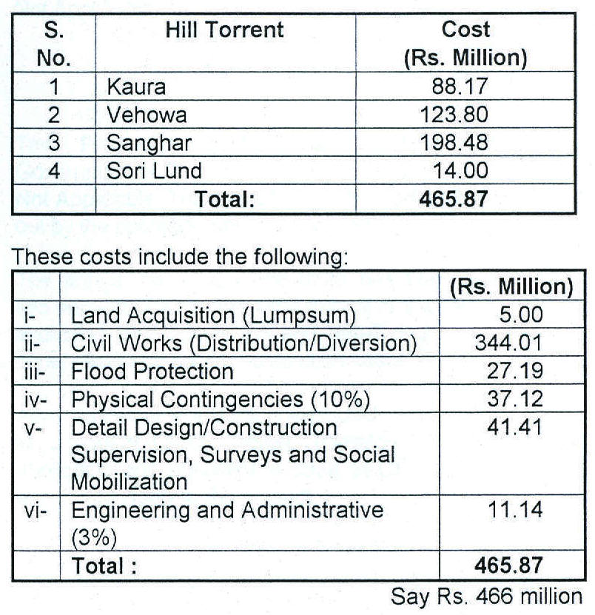

24. Allocation of Costs between Different Projects and Basis of Allocation: (for multipurpose projects only) | Not Applicable
25. Basis of cost estimates | For estimation of costs of various works proposed in the recommended package, unit rates have been adopted from the Composite Schedule of Rates (CR5) provided by the Finance Department of the Government of Punjab Province of Pakistan for the Year-2004. These rates have been derived from the relevant website of the Government of Punjab.
 | The item rate package comprises over 180 pages, of which the rates given under following titles, relating to recommend works were picked up:
• Earthwork (Excavation and Embankments);
• Stone Masonry;
• Concrete; and
• Protection and Diversion Works.
26. Annual Phasing of Works and Expenditure (Rs. Million) | The implementation of the Project has been planned under a 3-Year financial investment. Under the schedule, the year-wise allocation has been anticipated as under:
i Year-I Rs. 235.43 million
ii Year-2 Rs. 161.30 million
iii- Year-3 Rs. 69.13 million
27. Unit Costs:
(a) Facilities e.g. per Tubewell | Not Applicable
(b) Output e.g. per acre-foot of water | Not Applicable
28. Annual Operating Costs of Project after Completion:
(a) Agency Responsible | The Provincial Irrigation and Power Department, Government of Punjab.
(b) Handover Arrangements (Indicate Operational Arrangements) | Not Applicable. The execution of structures shall be carried out by the operating department itself.
(c) Cost break-up | The annual recurring expenditure has been estimated at two percent (2%) on the initial capital civil works investment excluding land acquisition and detail design, construction supervision and social mobilization costs.

29. Financing Plan
(a) Donor’s Contribution (Donor’s Name) | Asian Development Bank is expected to finance the Project as a part of CRBC Project. Therefore all the conditions applicable and prevalent in case of CRBC Project, would expectedly apply to this Project.
(b) Government’s Contribution
(c) Beneficiaries Contribution
(d) Detail of Donor’s Share (grant, loan, etc.)
30. Direct Financial Revenue of the Project
i Water Rates  ii- Land Revenue  iii- Cess (Drainage or Flood etc.)  iv- Out Receipts | Not Applicable
31. Financial Results
i) Annual Expenditure, Rs. Million | The annual expenditure of various components of the Project have been summarized below:
First Year - Rs. 235.43 million
Second Year - Rs. 161.30 million
Third Year - Rs. 69.13 million
ii) Annual Receipts | Economic benefits of the Project comprise:
i) increase in agricultural output in Pachad Area
ii) flood protection in Command Area
iii) social uplift
 | No revenue has been proposed in the feasibility studies. Therefore the Project Plan does not include any direct receipts
iii) Deficit or Surplus | Not Applicable
32. Economic Benefits
i) Annual Expenditure | All economic costs and benefits of the project are expressed in constant 2004 values, and only directly quantifiable costs and benefits have been included in the analysis. The total financial project costs are estimated about Rs. 466 million which have been converted to economic process by removing the distortions due to monetary and fiscal policies. After the adjustment, the total economic capital cost of the project is Rs. 417.08 million. The annual phasing of the Project Cost is thus:
First Year = Rs. 208.54 million
Second Year = Rs. 145.98 million
Third Year = Rs. 62.56 million
 | The economic value of incremental of operation and maintenance for the Project is Rs, 7.59 million.
ii) Annual Benefits | The annual maximum potential benefits on account of increase in agricultural production and avoidance of flood damages after the completion of Project works are estimated as Rs. 38.22 million and Rs. 18.26 million respectively. The aggregate annual benefits are thus about Rs. 56.5 million. These assumed to increase at an annual rate of 5 percent up to 10th year beyond which they may be constant, which work out to be about Rs. 92 million.
iii) Deficit or Surplus | Not applicable
iv) Benefit Cost Ratio | The Project Economic Parameters are as follows:
 | (Rs. Million)
 | 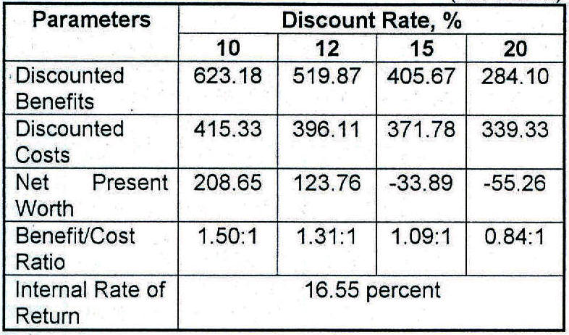
33. Risk and Sensitivity Analysis | Sensitivity of the overall project economic indices have been tested for the cases of cost over-run, reduced benefits and both cost over-run and benefit reduction simultaneously. The results are summarized below:
 | 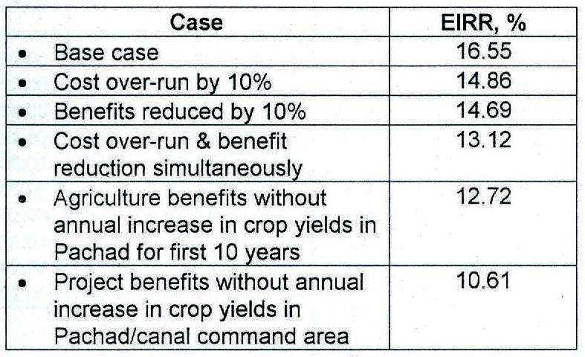
 | Sensitivity analyses indicate that the public investment on the Project remains economically feasible across the presumed range of assumptions.
34. Attached Cash Flow Statement (for large projects costing over Rs. 100 million) | Attached Table 4
35. Direct Employment | No new recruitment or openings are foreseen as the Implementing Agency has the requisite man-power already available. However, as procurement of the civil works shall have to be got done through the Contractors, it is expected that about a thousand persons (semi skilled and unskilled) shall remain employed for about 3 Years.
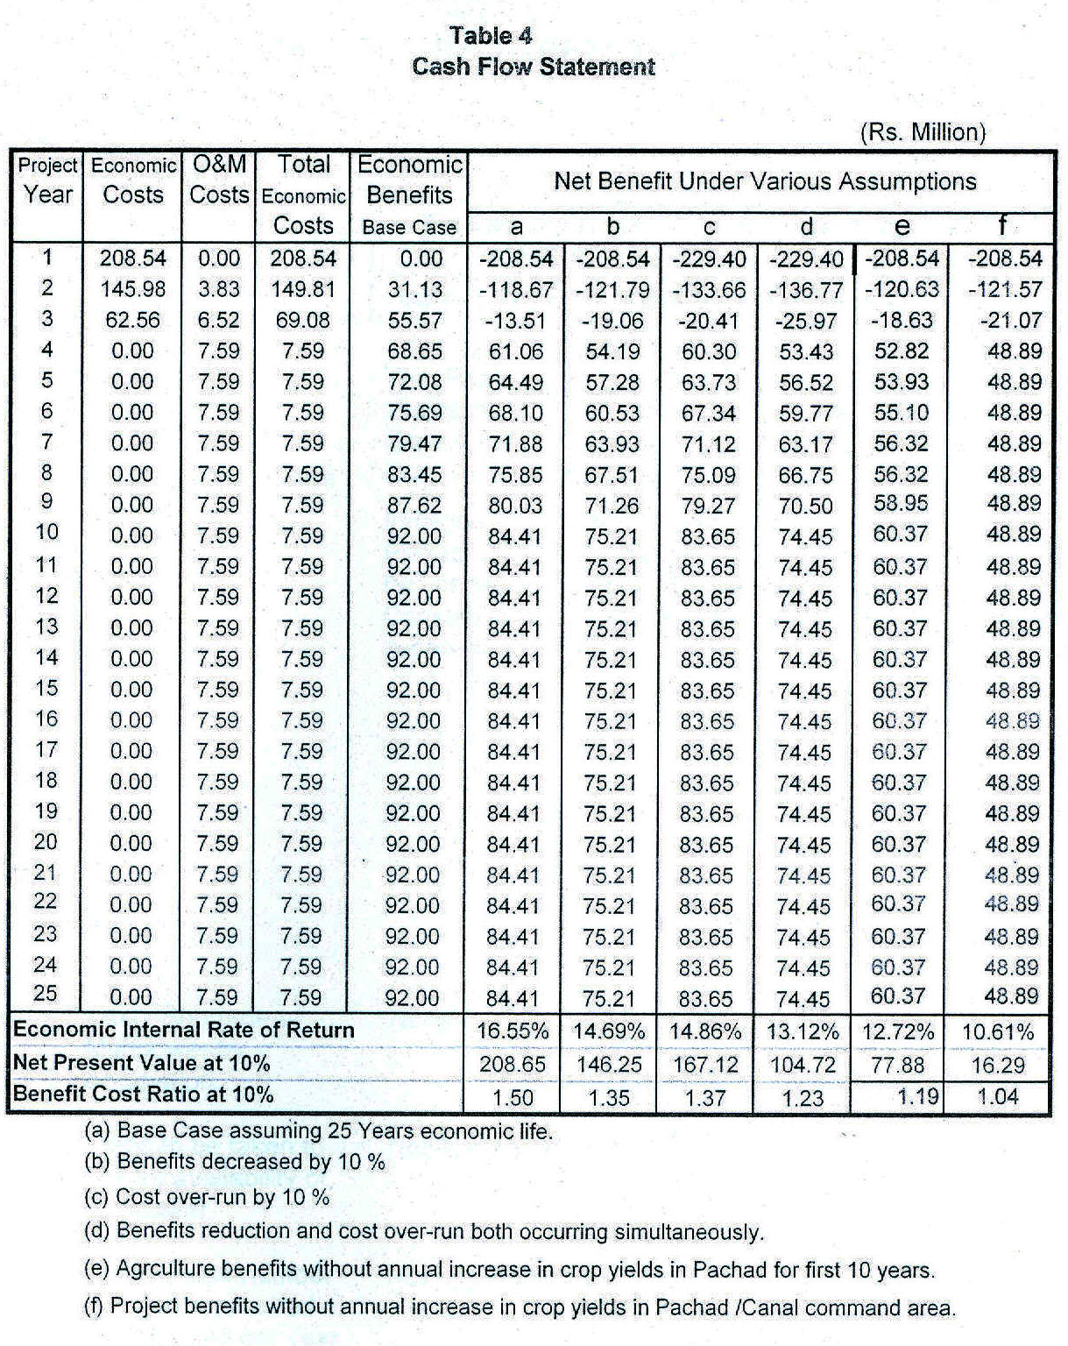

PART—C
PROJECT REQUIREMENTS

36. (a) Manpower

 |  | For Execution (Man-months) |  |  | For Operation (Number)
 |  | Male | Female | Total | Male | Female | Total

i) Professional and Technical | The Project shall be operated by the existing staff available with Irrigation and Power Department, Government of Punjab. Skilled and unskilled labour shall be arranged by the Contractors.
ii) Administrative Executive and Managerial | Irrigation and Power Department, Government of Punjab shall appoint/approve Consultants who would be engaged to provide technical supervision as Consultants. The Department shall provided overall supervisory services.
iii) Clerical
iv) Sales
v) Service
vi) Skilled
vii) Unskilled
viii) Others
36. (b) Likely Shortage of Manpower by occupation. | None
36. (c) Steps to be taken to ensure availability of manpower. | Not Applicable
36. (d) Approximate number of persons required to be trained per year (locally and abroad) and the kind of skills to be learnt. | Not Applicable
36. (e) Give total capital outlay. Give the Capital cost of mobilizing one worker for one shift. | Not Applicable

37. Physical and other facilities required for the Project

Item | Total | To be provided from the Project itself | To be provided from the Public utility

- Access Roads | The required facilities already exist in the Project area. No new extension of the existing facilities are therefore envisaged under the Project.
ii. Railway siding
iii. Fuel and Power
iv. Water and other utilities
v. Education facilities by type
vi. Public-Health Requirements
vii. Housing by type
viii. Others
38. To be completed only for major items costing more than 10% of the total cost

Item | Unit | Local |  |  | Foreign
 |  | Qty | Rate | Total | Qty | Rate | Total

- Material  ii) Supplies & Spares  iii) Equipment and machinery | The procurement of materials and supplies for each contract under this Project will be through the suppliers and the Contractors. They will themselves be responsible for procurement and supplies. The material required for civil works are available in the country.
a)
b)
c)
d)
e)
39. Material, spares, supplies and equipment for operation of Project

Item | Unit | Local |  |  | Foreign
 |  | Qty | Rate | Total | Qty | Rate | Total

- Material  - Earthwork  - Stone work  - Carriage of stone | Rte of these items were taken according to latest CSRs as already explained under item-25.
ii) Supplies and Spares | Nil
a)
b)
c)
iii) Equipment | Bulldozers, Scrapers, Excavators, Compactors etc. shall be arranged by the Contractors.
a)
b)
c)

iv) Material spares and supplies and equipment for the operation of Project | Would be supplied by the Contractors.
40. In the case of imported material and equipment for execution, indicate:
a) Justification for Imports | Not required
b) Proposed source of supply | Not required

THE FOLLOWING WORDS GOT LOST SOMEHOW
inter-alia,

the and laid

The area between the foot hill of Suleiman Range and the canal cornrnand or the Indus River in DG Khan Division of Punjab Province of Pakistan.

